Predicting Earth-Like Similarity in Exoplanets using Machine Learning

DS-450: Data Science Senior Capstone
Samia Mahmood
smahmood@bellarmine.edu
March 6, 2026

Abstract
Data was analyzed from NASA’s Exoplanet Archive dataset which contains over one million data points and over 6,071 confirmed exoplanets discovered by space- and ground-based missions. Using supervised learning with K-Nearest Neighbor (KNN) classification, the Earth-Like similarity in exoplanets was predicted and their habitability potential was determined by identifying the top 10 Earth-Like exoplanets. Using unsupervised learning clustering algorithms including K Means Clustering, Gaussian Mixture Model (GMM), and Hierarchical Density-Based Spatial Clustering of Applications with Noise (HDBSCAN). The top 10 Earth-Like exoplanets were characterized into planetary categories based on their natural groupings. These natural groupings confirmed that the top 10 Earth-Like exoplanets orbit a Sun-Like star within its Habitable Zone (HZ) within the Galactic Habitable Zone (GHZ) of the Milky Way Galaxy. By implementing a scalable and reproducible exploratory data analysis, exoplanets were characterized based on their mass-radius relation. This analysis demonstrated the application of computational modeling in Astronomy and Astrophysics analyses to provide meaningful insights into exoplanet characteristics and habitability potential while accelerating the discovery process of exoplanets.
Introduction
Within the past decade, significant improvements in high-precision space missions along with improved computational methodologies have enabled more advanced data analysis at a greater scale while fundamentally shaping our understanding of the Galaxy [1]. In 2009 NASA launched the Kepler mission to search for primarily Earth-Sized exoplanets orbiting the habitable zone (HZ) of Type-G (Sun-Like) stars [9]. Following its completion, Kepler’s successors, K2 and TESS, extended the search to include exoplanets orbiting brighter and closer stars which helped improve occurrence-rate estimates. Each three telescopes can be referenced in (Figs. 1 – 3). As of 2026, over 6,071 confirmed exoplanets have been discovered, primarily through Transit and radial velocity surveys, with a majority of exoplanets identified by the Kepler, K2, and TESS missions [16].
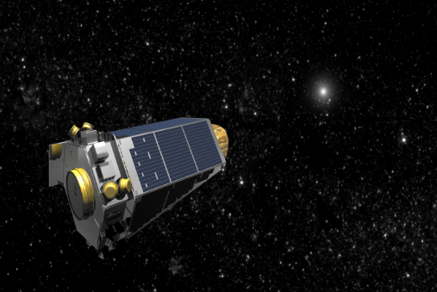  Figure 1: Artist depiction of the Kepler telescope | 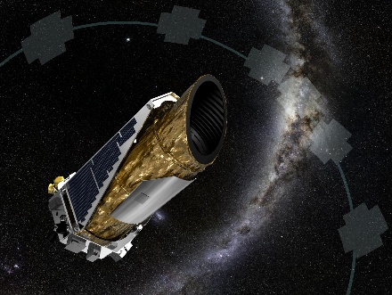  Figure 2: Artist depiction of the K2 telescope | 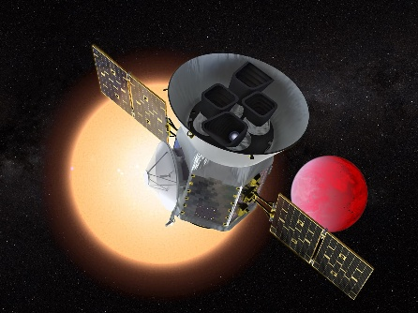  Figure 3: Artist depiction of the TESS telescope

These missions transformed planetary science by increasing statistical analysis of high-precision data while leading to a rapid growth in data volume. This as a result, has necessitated the adoption of data-driven methodologies and machine learning techniques for efficient analysis and interpretation. As the number of exoplanet detections continues to rapidly increase, characterizing these planets and assessing their Earth-like similarity and potential for harboring life has posed major challenges due to data variability, data incompleteness, and high dimensionality of astronomical data. The focus of this study is to employ data-driven methodologies by utilizing machine learning with exploratory data analysis (EDA) to conduct predictive analysis and analyze the key features from NASA’s Exoplanet Archive data by building upon previous work conducted by [28].
Background and Related Work
- Earth-Like Similarity and Habitability Potential Criteria
An Earth-Like exoplanet capable of sustaining life is determined by whether it is a rocky Earth-sized or Super-Earth-sized planet orbiting Sun-like (G-type) Main Sequence stars within the star’s Habitable Zone (HZ) inside the Galactic Habitable Zone (GHZ) of the Milky Way Galaxy in accordance with established Astro biological models. [10], [22]. This study ensures computation results align with established astrophysical criteria and subsequently seeks to enhance our understanding of exoplanet classification, Earth-Like similarity, and habitability potential.
Exoplanet’s host stars are classified by their star types: M, K, G (Sun-like), F, A, B, or O (Fig. 4). The star type describes the effective stellar temperature, stellar radius, stellar mass, and lifetime of the host star. Star types of A. B, and O are unlikely to support life due to their short lifespans caused by their high mass drives nuclear fusion at a faster pace, leading them to burn out before a planet capable of sustaining life can form. Host stars are also classified by their luminosity class based on the Hertzsprung-Russell diagram (Fig. 5). This includes Main Sequence (V) stars, Sub-Giants (IV), Giants (III), Bright Giants (II), Super Giants (I), and White Dwarfs (WD). The luminosity class of host stars depends on the luminosity, apparent brightness, and effective stellar temperature.
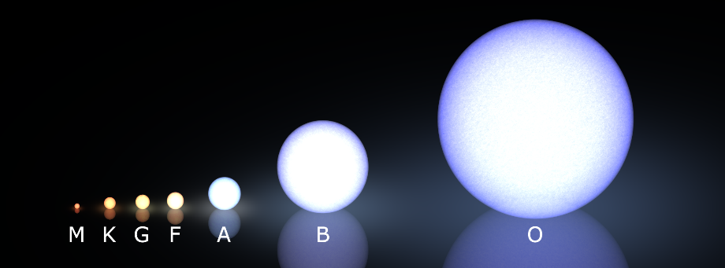  Figure 4: Diagram shows the different star types in order of coldest and longest lifetime to hottest and shortest lifetime | 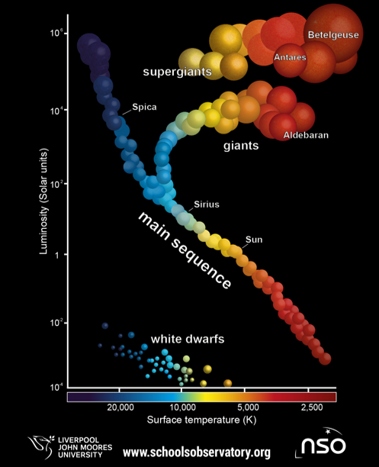  Figure 5: Diagram shows the different luminosity classes and the life stages for stars

The star’s Habitable Zone (HZ) depends on the star type (Fig. 6) and describes the optimal distance between the exoplanet and its host star range for liquid water to be sustained which is required for habitability (Fig. 7). Earth-Like similarity depends on the distance within 1 AU (Astronomical Unit). The Galactic Habitable Zone (GHZ) refers to the area within the Milky Way Galaxy which can sustain life due to reduced radiation compared to the spiral arms of the galaxy (Fig. 8).
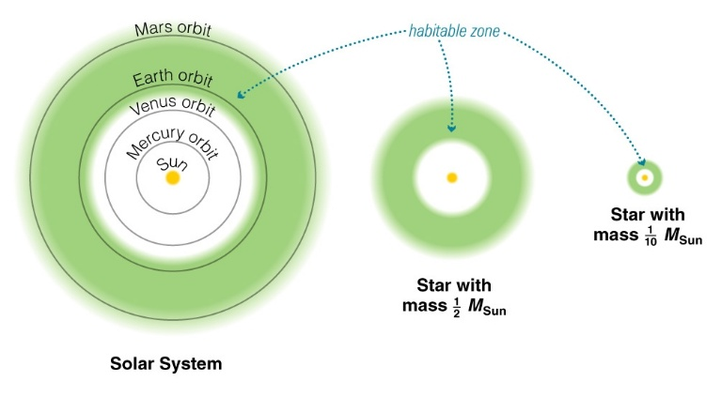  Figure 6: Diagram shows the location of the Habitable Zone which depends on the star type  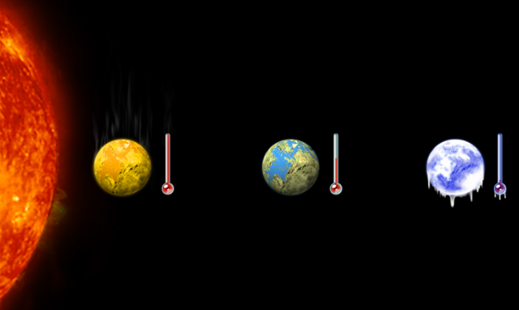  Figure 7: Diagram depicts an artist’s rendition showing an exoplanet too hot to sustain water, too cold to sustain water, and Earth which is at optimal distance to hold water. | 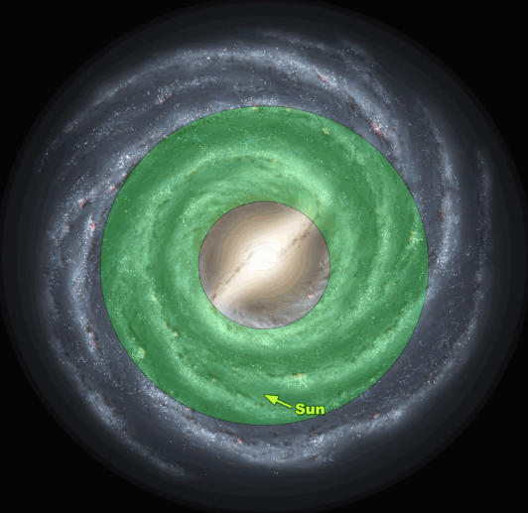  Figure 8: Diagram shows the Galactic Habitable Zone of the Milky Way Galaxy

- Previous Work Conducted
Early analysis of exoplanet data characterized planets based on their similarity to Earth and measured their habitability potential by developing habitability scoring frameworks. The Earth Similarity Index (ESI) developed by [18] quantitatively measures how Earth-like an exoplanet is based on four select features: planet surface temperature, planet density, planet mass, and escape velocity. Another habitability scoring metric developed by [18] is the Planetary Habitability Index (PHI) which is based on interior chemistry of the exoplanet to determine the planet’s potential for sustaining life through the presence of liquid water. Another habitability index used is the Biological Complexity Index (BCI) proposed by [19] which focused on the biological and chemical composition, geophysical properties, age, and temperature of the planet to determine their potential for habitability. Similar to the Earth Similarity Index, the Cobb-Douglas Habitability Score (CDHS) was developed by [20], [21] and calculated using the parameters: planet surface temperature, planet density, planet mass, and escape velocity for planetary habitability assessments. Studies based on the ESI habitability metric have been conducted by the University of Puerto Rico at Arecibo from the Planetary Habitability Laboratory (PHL) [29].
Prior studies utilized EDA with machine learning model comparison studies to characterize exoplanets, determine planet habitability, and explore parameter relationships [2], [3], [8], [11], [17]. Methods focusing on hybrid feature-selection to balance predictive performance and computational efficiency have been conducted by [7]. Applications of machine learning for astronomical data have leveraged supervised learning for classification and regression analyses. Research focused on exoplanet detection, false positive mitigation, and validation pipelines has utilized decision tree-based modeling for regression analysis along with K-Nearest Neighbor (KNN) and support vector machine-based modeling for transit classification [4], [23], [24]. Research conducted to estimate Earth similarity and perform habitability assessment has applied deep learning and regression modeling primarily through Decision Tree based modeling and Support Vector Machine learning algorithms [4], [5], [6].
In recent years, deep learning has transformed astrophysical and astronomical analysis. Convolutional Neural Networks (CNNs) paired with classification algorithms such as with K-Nearest Neighbor (KNN) have been used to classify transit detections and perform candidate validation [25]. CNN pipelines have been used to specifically detect weak shallow transit signals, further improving the efficiency of false-positive categorization [12]. Further research to improve sensitivity for Earth-Sized exoplanets and characterize noise sources using CNN architecture and TESS candidate vetting have been conducted by [13], [14], [15], [26]. While a majority of studies conducted on exoplanet data have utilized supervised learning, research conducted by [27] has recently introduced the application of unsupervised learning using K-Means clustering for exoplanet classification.
Objective
Prior works have relied primarily on supervised learning for habitability predictions based on predefined habitability scoring metrics. Additionally, prior works have utilized EDA for planet characterization. However, none have incorporated unsupervised learning for Earth-Like similarity predictions, and few have utilized an EDA and machine learning integrated workflow. Therefore, this study integrates unsupervised learning and supervised learning with a scalable reproducible EDA workflow to predict Earth-Like similarity by identifying top Earth-like candidates, evaluating their habitability potential, determining their natural planetary groupings, categorizing them based on key planetary and stellar features such as their mass and radius, and exploring relationships between stellar and planetary features.
Supervised machine learning through K-Nearest Neighbor (KNN) is used to automatically produce a list of the top 10 Earth-Like exoplanets and insight into their habitability potential. A predefined target row corresponding to Earth is used to compare all planetary and stellar features of all exoplanets to Earth and the Sun respectively. Unsupervised learning through K Means Clustering, Gaussian Mixture Model (GMM), and Hierarchical Density-Based Spatial Clustering of Applications with Noise (HDBSCAN) are used to predict exoplanet’s Earth-Like similarity by identifying their natural planetary groupings without a predefined planetary label. The results from all three clustering models are compared to evaluate overall result robustness. Exploratory data analysis is used to view relationships between stellar and planetary features, classify exoplanets into specific categories through an analysis of their key features, and characterize exoplanets based on their mass-radius relation.
Materials and Methodology
- Software Tools
This study uses Python due to its interpretable syntax and vast ecosystem of libraries used for analysis and modeling. For data handling and preprocessing, the Pandas and NumPy libraries will be utilized to allow for data manipulation, data cleaning, filtering, and handling missing data for high-dimensional datasets. These steps will be conducted to prepare the data for modeling which is conducted using the Scikit-learn library. This enables the creation of machine learning workflows and data pipelines. The Matplotlib and Seaborn libraries are used for data visualizations to generate plots and display feature distributions, heatmaps, and bar graphs. Jupyter Notebook will be utilized for the development environment to display analysis workflow and aid in reproducibility due to its ability to integrate code, visualizations, and documentation.
- Initial Dataset Description
The data used for this analysis is sourced from the NASA Exoplanet Archive which is an exoplanet catalog for all exoplanets detected by ground- and space-based telescopes. This dataset contains key planetary and stellar features which are mostly measured properties overserved by telescopes while some are calculated properties. These features can be used to categorize planets, determine their similarity to Earth, and habitability potential.
The raw dataset contained 39,235 rows and 92 columns. This dataset presents several analytical issues. There are typographical errors, redundant attributes, key features with missing data, and duplicate rows for a particular exoplanet, where each duplicate row corresponds to observations sourced by different authors. These duplicate rows contained varying data which must be consolidated.
- Initial Data Cleaning and Preprocessing
Initial preprocessing steps were taken to delete redundant features, rename columns, and ensure typographical inconsistencies were addressed. This left 24 columns remaining.
The following Table 1 summary shows 3 of the 24 features of the cleaned dataset $D_{\text{cleaned}}$used for conducting additional data preprocessing. This includes their data types, data designation, and percentage of missing data.
Variable Name | Definition | Data Type | Missing Data (%)
default_flag | Describes whether the specific parameters of an exoplanet for a given publication is the most scientifically reviewed by NASA (binary 1 or 0) | float64, nominal | 0%
solution_type | Describes whether the exoplanet is confirmed or a TESS candidate | Object, nominal | 0%
planet_controversy_flag | Describes whether the exoplanet is controversial (whether its current classification is disputed) (binary 1 = disputed or 0 = not disputed) | float64, nominal | 0%
Table 1 shows the 3 of the 24 features of the cleaned dataset.

The following Table 2 summarizes the 21 key features of the cleaned dataset $D_{\text{cleaned}}$ before conducting additional data preprocessing. This includes their data types, data designation, and percentage of missing data.
Variable Name Abbreviated | Variable Name | Definition | Data Type | Missing Data (%)
planet_name | Planet Name | Name of exoplanet | Object, nominal | 0%
host_star_name | Host Star Name | Name of the host star | Object, nominal | 0%
star_number_per_system | Star Number Per System | Number of stars in the exoplanet’s solar system | float64, ratio | 0%
discovery_method | Discovery Method | The discovery method used to detect the exoplanet | Object, nominal | 0%
year_of_discovery | Discovery Year | The year the exoplanet was discovered | float64, interval | 0%
discovery_facility | Discovery Facility | The facility (observatory/laboratory/Institution) which detected the exoplanets | Object, nominal | 0%
orbital_period_day | Orbital Period | The time it takes an exoplanet to complete one revolution around its host star (measured in Earth days) | float64, ratio | 5.24%
orbit_semi_major_axis_au | Orbital Semi Major Axis | The distance between an exoplanet and its host star (measured in AU – Astronomical Unit which refers to the distance between the Earth and the Sun) | float64, ratio | 5.09%
planet_rad_earth_rad | Planet Radius | Radius (size) of exoplanet (measured in Earth Radius) | float64, ratio | 24.91%
planet_mass_earth_mass | Planet Mass | Mass of exoplanet (measured in Earth Mass) | float64, ratio | 47.62%
planet_equil_temp_k | Planet Equilibrium Temperature | Exoplanet equilibrium (average surface) temperature (measured in terms of Kelvins) | float64, ratio | 26.90%
spectral_type | Spectral Type | Host star classification which describes a stars luminosity class (whether it is Main Sequence, Sub-Giant, Red Giant, Super Giant, White Dwarf, Brown Dwarf, etc,) and it also describes the star type (whether it is a type M, K, G, F, A, B, O) | Object, nominal | 68.57%
stellar_effective_temp_k | Stellar Effective Temperature | Host star’s effective (surface) temperature (measured in terms of Kelvins) | float64, ratio | 7.68%
stellar_rad_solar_rad | Stellar Radius | Radus (size) of host star (measured in Sun Radius) | float64, ratio | 9.98%
stellar_mass_solar_mass | Stellar Mass | Mass of host star (measured in Sun Mass) | float64, ratio | 0.66%
stellar_surf_grav | Stellar Surface Gravity | Surface gravity of the host star which describes the strength of the gravitational force acting on the surface of the host star | float64, ratio | 10.69%
orbital_eccentricity | Orbital Eccentricity | Describes how elongated (elliptical) the orbit of an exoplanet is. | float64, ratio | 14.87%
distance_parsec | Distance in Par Seconds | Describes the distance between Earth and the particular exoplanet (measured in par seconds) | float64, ratio | 2.03%
stellar_metallicity | Stellar Metallicity | Describes the abundance of heavier elements in a star | float64, ratio | 11.68%
planet_mass_jupiter_mass | Planet Mas in Jupiter Mass | Radius (size) of exoplanet (measured in Jupiter Radius) | float64, ratio | 24.91%
planet_radius_jupiter_radius | Planet Mass in Jupiter Radius | Mass of exoplanet (measured in Jupiter Mass) | float64, ratio | 24.91%
Table 2 shows the 21 key features of the cleaned dataset.
- Outlier Detection
To address the issue of duplicate rows for a given exoplanet with varying data per row, these values must be consolidated by grouping these duplicate rows into an exoplanet group then combining these duplicate rows into a single row for a given exoplanet group. Allowing for a single unique row to correspond to a single unique exoplanet.
However, to combine these rows into a single row without arbitrarily removing observations, an outlier detection algorithm was developed to identify potentially inconsistent measurements within each exoplanet group per column. Exoplanets were grouped by name, and the Z-Score method was then applied to each exoplanet group. The population mean and population standard deviation were computed after excluding missing values. If the standard deviation was less than or equal to 0.01, the variability was considered negligible, and no outliers were flagged for that column. If sufficient variability present, the z-score for each entry was computed using the following formula:
$$z=\frac{x-μ}{σ}$$
where $σ$ is the population standard deviation, $μ$ is the population mean, and x represents the observed entry value.
For most numerical features, a threshold of 3 standard deviations was used in accordance with a 99.7% confidence interval. Observations with absolute Z-scores greater than 3 were flagged as outliers. However, for sensitive stellar parameters such as stellar mass and stellar radius, a stricter threshold of 1 standard deviation was applied to better capture subtle inconsistencies in reported measurements. The outlier detection algorithm flagged 23,151 individual entries as outliers.
Any entry flagged as an outlier that also had a “default flag” value of 1 was retained in the dataset, as these measurements are heavily verified by NASA. This allowed for the consolidation of all published observations of exoplanets while preserving the accuracy of default flag entries. Of the 23,151 individual entries flagged as outliers, 3,582 individual entries belong to a default flag row. After retaining these 3,582 entries, this left a total of 19,569 individual entries flagged as outliers. Entry values flagged as outliers were automatically replaced with null values. This approach preserves other valid measurements within the same observation while preventing extreme values from skewing statistical analyses. Replacing outliers with null values avoids incorrectly implying a true measurement of zero, which would misrepresent the physical meaning of the data parameter.
- Unconfirmed Exoplanet Removal
After handling outliers, filtered dataset $D_{\text{filtered}}$ was obtained by selecting entries from the cleaned dataset from $D_{\text{cleaned}}$ where the rows corresponding to unconfirmed exoplanets classified as “TESS Project Candidate” were filtered out based on their “solution type” and controversial exoplanets with a “planet controversy flag” value of 1 were excluded from the filtered dataset. This can be visualized in the following expression:
$$D_{\text{filtered}}=\{x∈D_{\text{cleaned}} | X_{\text{solution_type}}≠ "TESS Project Candidate" ∧ planet_controvery_flag = 0\}$$
- Handling Duplicate Observations
After removing the outliers and restricting the data to confirmed exoplanets only, a duplicate row reduction algorithm using a custom aggregation function was created where numerical columns were aggregated by the mean and categorical columns were aggregated by the mode. This combined the duplicate rows into a single row for a given exoplanet group. If this aggregated mean or mode values deviated more than 15% of the default flag value, then the default flag value was retained to align with the most reliable or authoritative recorded measurement for that exoplanet. This resulted in 6,071 confirmed exoplanets remaining as of January 2026. The steps of the duplicate row reduction algorithm can be referenced below:
Let all duplicate rows corresponding to a given exoplanet P be grouped by the planet name to form an exoplanet group $G_{\text{p}}$ from the filtered dataset $D_{\text{filtered}}$:
$$G_{\text{p}}=\{x∈D_{\text{filtered}}| x_{\text{planet_name}}=P\}$$
For each categorical column $x_{\text{c}}$, the mode $X_{\text{p}\text{,c}}$ was used to aggregate columns within an exoplanet group $G_{\text{p}}$:
$$X_{\text{p}\text{,c}}=mode(\{x_{\text{c}}|x∈G_{\text{p}}\})$$
For each numerical column $x_{\text{n}}$, the mean $μ_{\text{p,n}}$ was used to aggregate columns within an exoplanet group $G_{\text{p}}$ however if this mean value deviated from the default value ${X_{\text{p}\text{,n}}}^{d}$ by a threshold $τ=0.15$, then the default value was used. Otherwise, the mean was used:
$$X_{\text{p}\text{,n}}=\left\{\begin{matrix}{X_{\text{p}\text{,n}}}^{d}, if \frac{\left|μ_{\text{p,n}} - {X_{\text{p}\text{,n}}}^{d}\right|}{\left|{X_{\text{p}\text{,n}}}^{d}\right|}>τ \\ μ_{\text{p,n}}, otherwise\end{matrix}\right.$$
Where:
$$μ_{\text{p,n}}=\frac{1}{\left|G_{\text{p}}\right|}\sum_{x ∈ G_{\text{p}}}{x_{\text{n}}}$$
- Missing Data and Imputation
The following Table 3 shows the percentage of missing data for all 21 features of the final filtered dataset $D_{\text{final}}$
Final filtered Dataset Features | % of Missing Data
spectral_type | 68.57%
planet_mass_earth_mass | 47.62%
planet_mass_jupiter_mass | 47.62%
planet_equil_temp_k | 26.90%
planet_rad_jupiter_rad | 24.91%
planet_rad_earth_rad | 24.91%
orbital_eccentricity | 14.87%
stellar_metallicity | 11.68%
stellar_surf_grav | 10.69%
stellar_rad_solar_rad | 9.98%
stellar_effective_temp_k | 7.68%
orbital_period_day | 5.24%
orbit_semi_major_axis_au | 5.09%
distance_parsec | 2.03%
stellar_mass_solar_mass | 0.66%
year_of_discovery | 0.00%
host_star_name | 0.00%
planet_name | 0.00%
discovery_method | 0.00%
star_number_per_system | 0.00%
discovery_facility | 0.00%
Table 3: shows the percentage of missing data in order of largest percentage missing to least percentage missing.
To impute for this missing data for orbital semi major axis and orbital period when the stellar mass is known, Kepler’s Third Law was utilized:
$$a = \sqrt[3]{T^{2}M_{s}} (where M_{s} = M_{star}/M_{sun})$$
Where $a$ is the orbital semi major axis, T is the orbital period, and $M_{s}$ is the stellar mass in terms of sun’s mass.
For missing stellar mass when the orbital semi major axis and orbital period are known, Kepler’s Third Law was used.
However, for any remaining missing stellar mass data, a secondary imputation method was used impute for missing stellar mass when the orbital semi major axis and orbital period are unknown, but the stellar surface gravity and the stellar radius are known. This method used the Universal Law of Gravitation:
$$g=\frac{GM_{s}}{{R_{s}}^{2}} (where R_{s} = R_{star}/R_{sun})$$
Where $R_{s}$ is the stellar radius in terms of sun’s radius, $M_{s}$ is the stellar mass in terms of sun’s mass, g is the stellar surface gravity, and gravitational constant $G =6.67430 x {10}^{-11}m^{3}{kg}^{-1}s^{-2}$.
Missing stellar surface gravity was imputed using the Universal Law of Gravitation as well where in this instance, the stellar radius and stellar mass are known.
To impute missing data for stellar effective temperature planetary equilibrium temperature when the stellar radius and orbital semi major axis are known, the Zero-Greenhouse Equilibrium Temperature of Exoplanet Equation was utilized:
$$T_{eq} =T_{eff}{(1 - A)}^{1/4} \sqrt{\frac{R_{s}}{2a}}$$
Where $T_{eq}$ is the planetary equilibrium temperature, $T_{eff}$ is the stellar effective temperature, $R_{s}$ is the stellar radius in terms of sun’s radius, $a$ is the orbital semi major axis, and A is the Bond Albedo constant which is used to describe the amount of light absorbed or reflected in a black-body model which is the model used for determining stellar and planetary temperatures. In this analysis, the Bond Albedo constant is assumed to be 0.5 which means the black body is neither highly dark nor highly reflective. This neutral assumption was chosen to avoid introducing bias or making overly specific assumptions in the absence of detailed albedo measurements for individual exoplanets.
For missing planet mass data and planet radius data, the Transit Method Mass-Radius Estimation was utilized. Existing literature establishes a general power-law relationship [30] in the form of:
$$M_{p} ={R_{p}}^{γ} (where M_{p}=M_{planet}/M_{earth} and R_{p}=R_{planet}/R_{earth})$$
Where $M_{p}$ is the planet mass in terms of Earth’s mass, $R_{p}$ is the planet radius in terms of Earth’s radius, and $γ$ is a scaling exponent whose value depends on the planet’s mass or planet’s size.
While prior works provide empirically derived mass-radius relations, this study adapts mass-radius relations to account for the mass-radius classifications defined in the exploratory data analysis section of this study. The mass-radius classification of exoplanets was divided into groups such as Earth-like, Super-Earth-like, Neptune-like, Super-Neptune-like, Saturn-Like, Super-Saturn-Like, Jumper-Like, and Super-Jupiter-Like. The corresponding $γ$ values were assigned to each class to better reflect their expected structural and compositional differences.
The classification rule to classify exoplanets by their radius $R_{p}$ is as follows:
$$\left\{\begin{matrix}\begin{matrix}\begin{matrix}Earth Like, R_{p}≤ 1.5 \\ Super-Earth Like, 1.5< R_{p} ≤ 2\end{matrix} \\ Neptune Like , 2< R_{p} ≤ 4 \\ \begin{matrix}Super-Neptune Like , 4< R_{p} ≤ 6 \\ Saturn Like, 6< R_{p} ≤ 9, \\ \begin{matrix}Super-Saturn Like, 9< R_{p} ≤ 11 \\ Jupiter Like, 11< R_{p} ≤ 15 \end{matrix}\end{matrix}\end{matrix} \\ Super-Juptier Like, R_{p} > 15\end{matrix}\right.$$
The classification rule to classify exoplanets by their mass $M_{p}$ is as follows:
$$\left\{\begin{matrix}\begin{matrix}Earth Like, 1≤ M_{p} < 2, \\ Super-Earth Like, 2≤ M_{p} < 8, \\ \begin{matrix}\begin{matrix}Neptune Like, 8≤ M_{p} ≤ 80, \\ Super-Neptune Like, 8≤ M_{p} ≤ 8\end{matrix} \\ Saturn Like, 80< M_{p} ≤ 150 , \\ \begin{matrix}Super-Saturn Like, 150< M_{p} < 318, \\ Jupiter Like, 318≤ M_{p} ≤ 3180,\end{matrix}\end{matrix}\end{matrix} \\ Super-Juptier Like, M_{p}> 3180 \end{matrix}\right.$$
The mass-radius relation with the associated scaling exponents used to impute missing planet mass are as follows:
$$\left\{\begin{matrix}\begin{matrix}\begin{matrix}Earth Like, M_{p} ={R_{p}}^{1.3}, (where γ = 1.3) \\ Super-Earth Like, M_{p} ={R_{p}}^{2.44}, (where γ = 2.44)\end{matrix} \\ Neptune Like , M_{p} ={R_{p}}^{1.9}, (where γ = 1.9) \\ \begin{matrix}Super-Neptune Like , M_{p} ={R_{p}}^{2.61}, (where γ = 2.61) \\ Saturn Like, M_{p} ={R_{p}}^{2.37}, (where γ = 2.37) \\ \begin{matrix}Super-Saturn Like, M_{p} ={R_{p}}^{2.63}, (where γ = 2.63) \\ Jupiter Like, M_{p} ={R_{p}}^{2.63}, (where γ = 2.63)\end{matrix}\end{matrix}\end{matrix} \\ Super-Juptier Like, M_{p} ={R_{p}}^{2.31}, (where γ = 2.31)\end{matrix}\right.$$
The mass-radius relation with the associated scaling exponent used to impute missing planet radius is the following:
$$M_{p} ={R_{p}}^{1/2.09} (where M_{p}=M_{planet}/M_{earth} and R_{p}=R_{planet}/R_{earth})$$
It is important to note that these imputations are approximations. Accurately determining planetary mass, particularly for distant exoplanets, remains challenging due to observational constraints inherent in current detection methods. This explains why much of the planet mass and radius were initially missing.
- Feature Engineering
After handling missing values, with the exception of spectral type, feature engineering was conducted to create key features for analysis. First, a stellar luminosity column was created in order to impute for the missing spectral type data based on the luminosity class information. This utilizes Stefan-Boltzmann Equation:
$$L_{s} ={R_{s}}^{2}{T_{eff}}^{4} (where L_{s}=L_{star}/L_{sun })$$
Where $L_{s}$ is the stellar luminosity in terms of the Sun’s luminosity, $R_{s}$ is the stellar radius in terms of sun’s radius, and $T_{eff}$ is the stellar effective temperature in Kelvin.
A planet radial velocity column was created using the Planet Radial Velocity formula:
$$v=\frac{GM_{p}}{a}$$
Where $M_{p}$ is the planet mass in terms of Earth’s mass, $a$ is the orbital semi major axis, the gravitational constant $G = 6.67430 x {10}^{-11}m^{3}{kg}^{-1}s^{-2}$, and v is the planet orbital velocity.
- Missing Spectral Type Imputation and Inconsistency Correction
Missing spectral type data was imputed based on the stellar mass, stellar radius, stellar effective temperature, and stellar luminosity in accordance with the Hertzsprung-Russell diagram in Fig 5. The boundaries are approximate and reflect typical main-sequence parameter ranges used in the literature.
The conditions for Main Sequence (V) stars with the associated star types O, B, A, F, G, K, and M are as follows:
$$OV = \left\{\begin{matrix}T_{eff} ≥ 30,000 K \\ M_{s} ≥ 16 \\ \begin{matrix}R_{s} ≥ 6.6 \\ L_{s} ≥ 30,000\end{matrix}\end{matrix}\right.$$
$$BV = \left\{\begin{matrix}{10,000 K≤T}_{eff}< 30,000 K \\ {2.1 ≤M}_{s}< 16 \\ \begin{matrix}{1.8≤R}_{s}< 6.6 \\ 25≤L_{s}< 30,000\end{matrix}\end{matrix}\right.$$

$$AV = \left\{\begin{matrix}{7,500 K≤T}_{eff}< 10,000 K \\ {1.4 ≤M}_{s}< 2.1 \\ \begin{matrix}{1.4≤R}_{s}< 1.8 \\ 5≤L_{s}< 25\end{matrix}\end{matrix}\right.$$
$$FV = \left\{\begin{matrix}{6,000 K≤T}_{eff}< 7,500 K \\ 1{.04 ≤M}_{s}< 1.4 \\ \begin{matrix}{1.15≤R}_{s}< 1.4 \\ 1.5≤L_{s}< 5\end{matrix}\end{matrix}\right.$$

$$GV = \left\{\begin{matrix}{5,200 K≤T}_{eff}< 6,000 K \\ 0.{8 ≤M}_{s}< 1.04 \\ \begin{matrix}{0.96≤R}_{s}< 1.15 \\ 0.6≤L_{s}< 1.5\end{matrix}\end{matrix}\right.$$
$$KV = \left\{\begin{matrix}{3.700 K≤T}_{eff}< 5.200 K \\ 0.45{ ≤M}_{s}< 0.8 \\ \begin{matrix}{0.7≤R}_{s}< 0.96 \\ 0.08≤L_{s}< 0.6\end{matrix}\end{matrix}\right.$$

$$MV = \left\{\begin{matrix}T_{eff}< 3.700 K \\ M_{s}< 0.45 \\ \begin{matrix}R_{s}< 0.7 \\ L_{s}< 0.08\end{matrix}\end{matrix}\right.$$
The conditions for Sub-Giant (IV) stars with the associated star types B, A, F, G, and K are as follows:

$$BIV = \left\{\begin{matrix}{10,000 K≤T}_{eff}< 30,000 K \\ {3 ≤M}_{s}< 16 \\ \begin{matrix}{3≤R}_{s}< 10 \\ 100≤L_{s}< 20,000\end{matrix}\end{matrix}\right.$$

$$AIV = \left\{\begin{matrix}{7,500 K≤T}_{eff}< 10,000 K \\ {1.5 ≤M}_{s}< 3 \\ \begin{matrix}{2≤R}_{s}< 4 \\ 10≤L_{s}< 60\end{matrix}\end{matrix}\right.$$

$$FIV = \left\{\begin{matrix}{6,000 K≤T}_{eff}< 7,500 K \\ 1{.2 ≤M}_{s}< 2 \\ \begin{matrix}{1.2≤R}_{s}< 5 \\ 4≤L_{s}< 20\end{matrix}\end{matrix}\right.$$
$$GIV = \left\{\begin{matrix}{5,200 K≤T}_{eff}< 6,000 K \\ 1{ ≤M}_{s}< 1.6 \\ \begin{matrix}{1.45≤R}_{s}< 6 \\ 2≤L_{s}< 20\end{matrix}\end{matrix}\right.$$

$$KIV = \left\{\begin{matrix}{3.700 K≤T}_{eff}< 5.200 K \\ 0.8{ ≤M}_{s}< 2.6 \\ \begin{matrix}{1.5≤R}_{s}< 8 \\ 1≤L_{s}< 25\end{matrix}\end{matrix}\right.$$

The conditions for Giant (III) stars with the associated star types O, B, A, F, G, K, and M are as follows:

$$OIII = \left\{\begin{matrix}T_{eff} ≥ 30,000 K \\ M_{s} ≥ 20 \\ \begin{matrix}R_{s} ≥ 15 \\ L_{s} ≥ 100,000\end{matrix}\end{matrix}\right.$$
$$BIII = \left\{\begin{matrix}{10,000 K≤T}_{eff}< 30,000 K \\ {5 ≤M}_{s}< 20 \\ \begin{matrix}{5≤R}_{s}< 20 \\ 1,000≤L_{s}< 100,000\end{matrix}\end{matrix}\right.$$

$$AIII = \left\{\begin{matrix}{7,500 K≤T}_{eff}< 10,000 K \\ {2≤M}_{s}< 5 \\ \begin{matrix}{5≤R}_{s}< 15 \\ 50≤L_{s}< 500\end{matrix}\end{matrix}\right.$$

$$FIII = \left\{\begin{matrix}{6,000 K≤T}_{eff}< 7,500 K \\ 1{.5 ≤M}_{s}< 3 \\ \begin{matrix}{5≤R}_{s}< 20 \\ 20≤L_{s}< 200\end{matrix}\end{matrix}\right.$$

$$GIII = \left\{\begin{matrix}{5,200 K≤T}_{eff}< 6,000 K \\ 0{ ≤M}_{s}< 3 \\ \begin{matrix}{8≤R}_{s}< 30 \\ 30≤L_{s}< 300\end{matrix}\end{matrix}\right.$$

$$KIII = \left\{\begin{matrix}{3.900 K≤T}_{eff}< 5.000 K \\ 0{ ≤M}_{s}< 3.8 \\ \begin{matrix}{8≤R}_{s}< 51 \\ 30≤L_{s}< 930\end{matrix}\end{matrix}\right.$$

$$MIII = \left\{\begin{matrix}{2.800 K≤T}_{eff}< 3.900 K \\ 1{ ≤M}_{s}< 5 \\ \begin{matrix}{20≤R}_{s}< 200 \\ 3≤L_{s}< 30\end{matrix}\end{matrix}\right.$$

The conditions for other spectral types including Whitw Dwarf (WD), Sub Dwarf B (sdB) for Pulsating Stars, and HW Virginis (HW Vir) for Eclipsing Binary Stars are as follows where $N_{s}$ refers to the number of stars in the planetary system:
$$WD = \left\{\begin{matrix}{4,700 K≤T}_{eff}< 16,000 K \\ M_{s}< 0.7 \\ \begin{matrix}R_{s}< 0.016 \\ L_{s}< 0.01\end{matrix}\end{matrix}\right.$$
$$sdB = \left\{\begin{matrix}{29,000 K≤T}_{eff}< 40,000 K \\ {0.4 ≤M}_{s}< 0.6 \\ \begin{matrix}{0.1≤R}_{s}< 0.25 \\ 23≤L_{s}< 85\end{matrix}\end{matrix}\right.$$
$$HW Vir = \left\{\begin{matrix}{29,000 K≤T}_{eff}< 40,000 K \\ {0.4≤M}_{s}< 0.5 \\ \begin{matrix}{0.1≤R}_{s}< 0.21 \\ \begin{matrix}23≤L_{s}< 85 \\ N_{s}= 2\end{matrix}\end{matrix}\end{matrix}\right.$$
After imputing missing spectral type values, the typographical inconsistencies within the spectral type column were addressed by removing white spaces, special characters and numbers, and ensuring spelling and capitalization were standardized.

- Habitable Zone Feature Creation
After imputing for all missing values, a habitable zone main sequence column was created to determine whether an exoplanet is within the habitable zone range of a Main Sequence star with a star type of M, K, G, and F since types O, B, and A cannot sustain life. If the planet is within the habitable zone, it has an assigned value of 1, if it is not within this range or if it orbits a non-Main Sequence star, it has an assigned value of 0.
A planet was considered potentially habitable if both its orbital semi major axis $a$ and planetary equilibrium temperature $T_{eff}$ fell within the habitable zone (HZ). The planetary equilibrium temperature is required to lie within the range:
$${235 K≤T}_{eff}≤ 330 K$$
The planet’s orbital semi major axis $a$ is required to lie within the habitable zone boundaries which are dependent upon the spectral type. This is then scaled the square root of the stellar luminosity $L_{s}$ A small tolerance of t = 0.001 AU was applied to the boundary condition to account for numerical precision. The boundary conditions for the habitable zone are defined as:
$$MV Habitable Zone: 0.07\sqrt{L_{s}} - t ≤a≤ 0.20\sqrt{L_{s}} + t$$
$$KV Habitable Zone: 0.10\sqrt{L_{s}} - t ≤a≤ 0.30\sqrt{L_{s}} + t$$
$$GV Habitable Zone:0.80\sqrt{L_{s}} - t ≤a≤ 1.70\sqrt{L_{s}} + t$$
$$FV Habitable Zone:1.50\sqrt{L_{s}} - t ≤a≤ 3.50\sqrt{L_{s}} + t$$

- Final Data Cleaning and Preprocessing
For any columns that were created or for which missing values imputed, any rows containing missing rows were removed due to the extensive missing data. This ensured that only meaningful data was used for analysis. Of the 6,071 confirmed exoplanets, approximately 10.74% exoplanets were removed, which left 5,419 confirmed exoplanets remaining for this analysis.
Additionally, any remaining columns whose missing values could not be imputed for using current known formulations were removed. Finally, feature selection was conducted to keep the most relevant features in the analysis. This resulted in 14 key features and 1 column representing the observations which are the unique exoplanets.

- Final Dataset Description
There are 5,419 confirmed exoplanets in the final dataset and 15 columns, out of which, 14 are key features. Table 4 displays all 15 features.
Variable Name | Definition
Planet Name | Name of exoplanet (Observation of the dataset)
Star Number Per System | Number of stars in the exoplanet’s solar system
Orbital Period | The time it takes an exoplanet to complete one revolution around its host star (measured in Earth days)
Orbital Semi Major Axis | The distance between an exoplanet and its host star (measured in AU – Astronomical Unit which refers to the distance between the Earth and the Sun)
Planet Radius | Radius (size) of exoplanet (measured in Earth Radius)
Planet Mass | Mass of exoplanet (measured in Earth Mass)
Planet Equilibrium Temperature | Exoplanet equilibrium (average surface) temperature (measured in terms of K - Kelvins)
Spectral Type | Host star classification which describes a host star’s luminosity class (whether it is Main Sequence, Sub-Giant, Red Giant, Super Giant, White Dwarf, Brown Dwarf, etc,) and it also describes the star type (whether it is a type M, K, G, F, A, B, O)
Stellar Effective Temperature | Host star’s effective (surface) temperature (measured in terms of K - Kelvins)
Stellar Radius | Radus (size) of host star (measured in Sun Radius)
Stellar Mass | Mass of host star (measured in Sun Mass)
Stellar Surface Gravity | Surface gravity of the host star which describes the strength of the gravitational force acting on the surface of the host star
Stellar Luminosity | Stellar luminosity describes the total energy emitted by the host star
Planetary Orbital Velocity | Planetary orbital velocity describes the speed at which the exoplanet travels around its host star
Habitable Zone | Binary variable describing whether a exoplanet is within its host star’s habitable zone (1) or not (0)
Table 4: Shows the 14 key features

- Exploratory Data Analysis
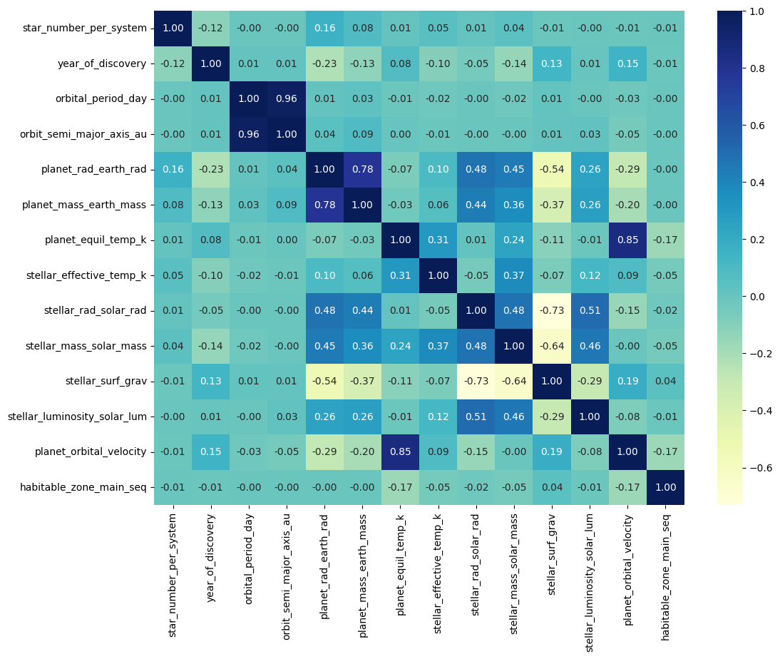
Figure 9: Heatmap which displays the correlation between all numerical features of the dataset

Based on the correlation heatmap for all numerical columns of the dataset (Fig. 9), there appears to be minimal to no correlation among a majority of the numerical features with a few features displaying moderate correlation. Orbital semi major axis and orbital period displayed the strongest positive correlation of 0.96, followed by Planet orbital velocity and planet equilibrium temperature however displayed a strong positive correlation of 0.85. Stellar surface gravity displays moderately strong negative correlation with stellar radius and stellar mass with correlation values of -0.74 and -0.64 respectively.
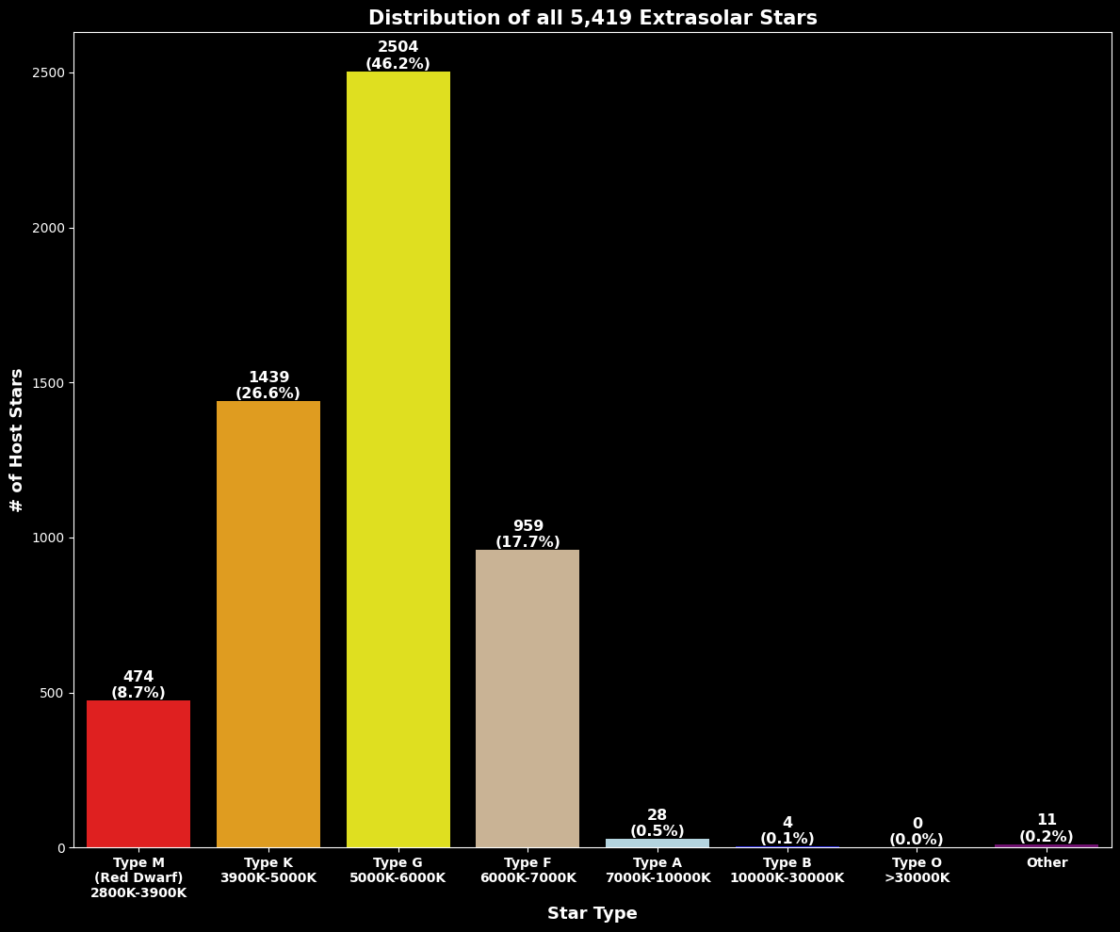
Figure 10: Bar Graph of the Distribution of all 5,419 Extrasolar Stars Characterized by spectral type

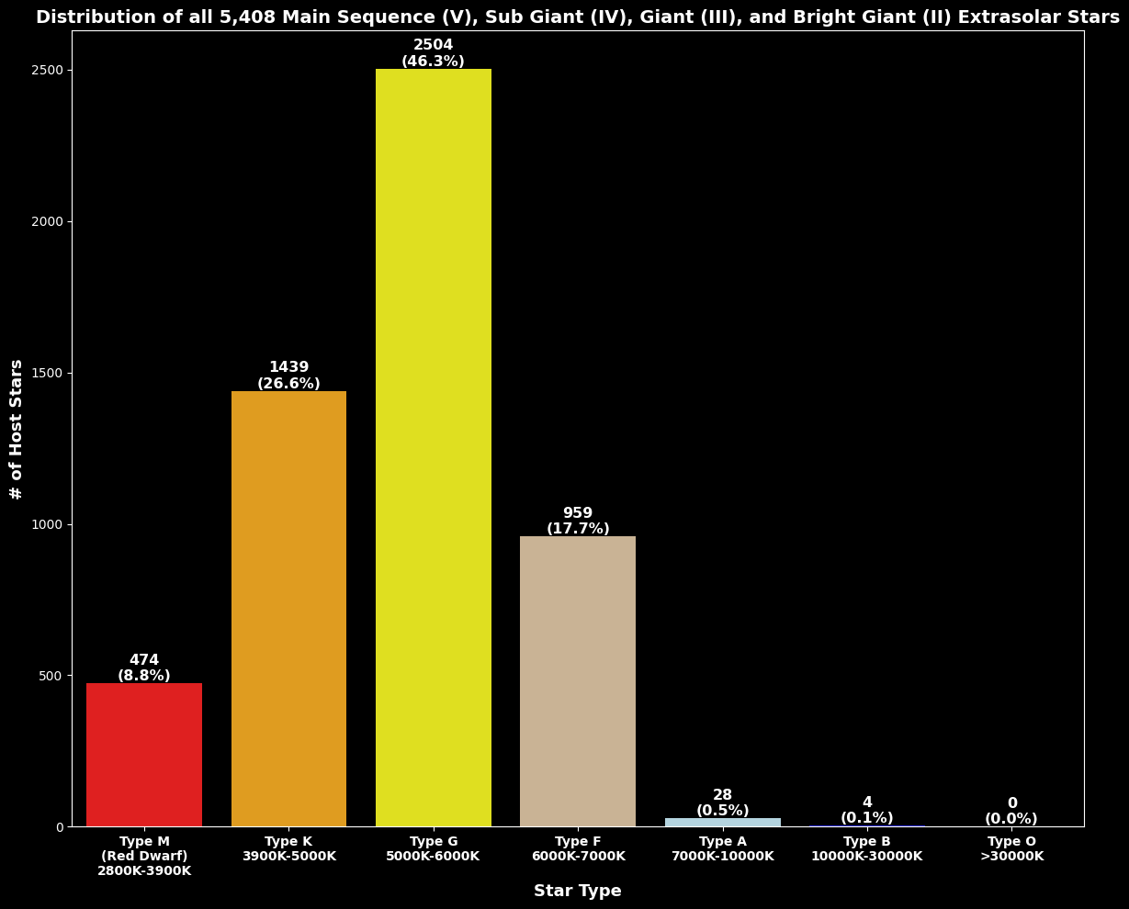
Figure 11: Bar Graph of the Distribution of all 5,408 Main Sequence (V), Sub Giant (IV), Giant (III), and Bright Giant (II) Extrasolar Stars Characterized by spectral type
.
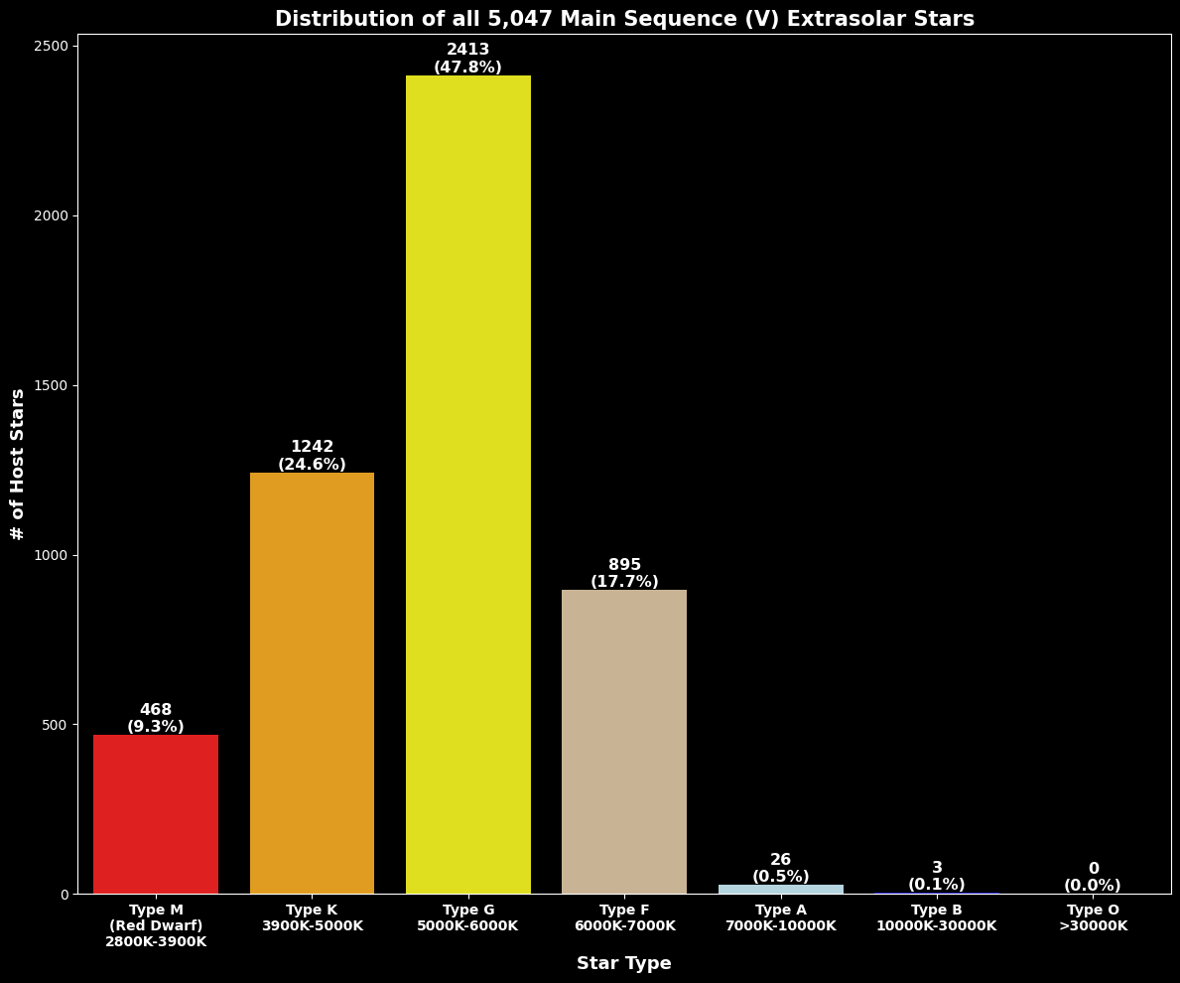
Figure 12: Bar Graph of the Distribution of all 5,047 Main Sequence (V Extrasolar Stars Characterized by spectral type

Based on the bar graph shown in (Figs. 10-12), Type-G (Sun-Like) stars appeared to be the most prominent star type for all extrasolar stars at 46.2%. When focusing on all extrasolar stars which do not include White Dwarfs, Pulsating Stars, and Eclipsing Binary Stars, a majority of stars remained to be Sun-Like stars at 46.3%. For just Main Sequence Stars, a vast majority of stars were Sun-Like at 47.8%. Given the expected relative abundance within the galaxy is approximately 7.6%,, these statistics imply Earth and surrounding exoplanets are in an area of the Galaxy abundant with Sun-Like stars.
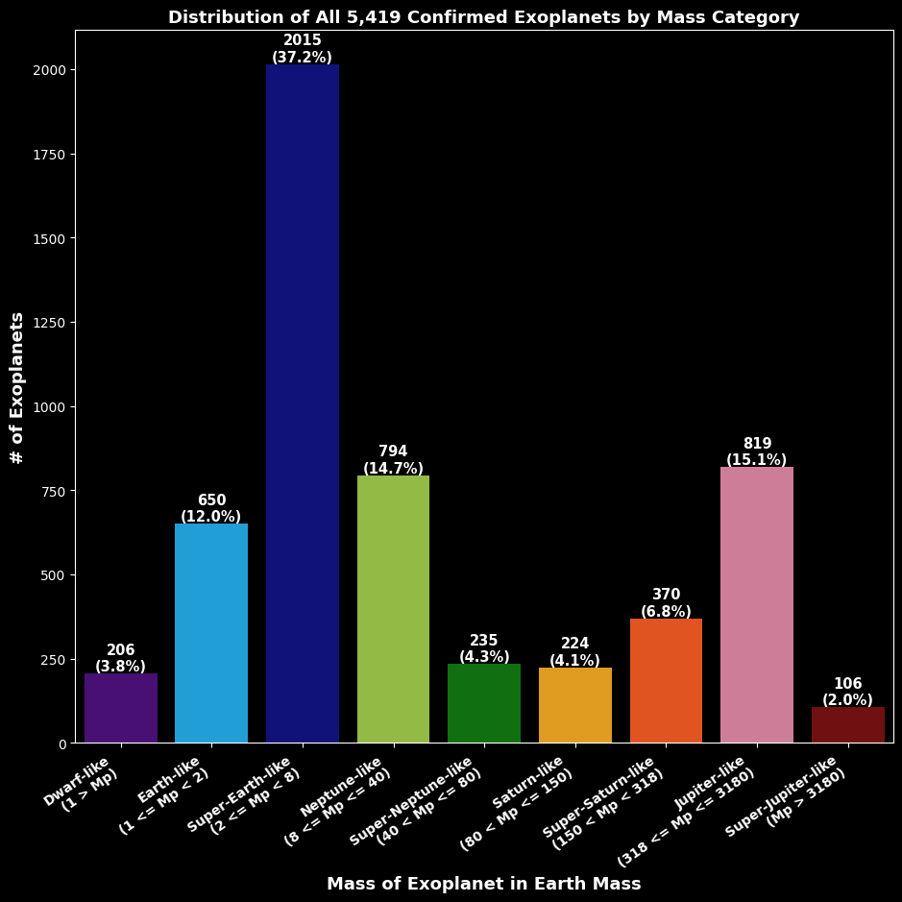
Figure 13: Bar Graph of the Distribution of all 5,419 Confirmed Exoplanets by Mass Category
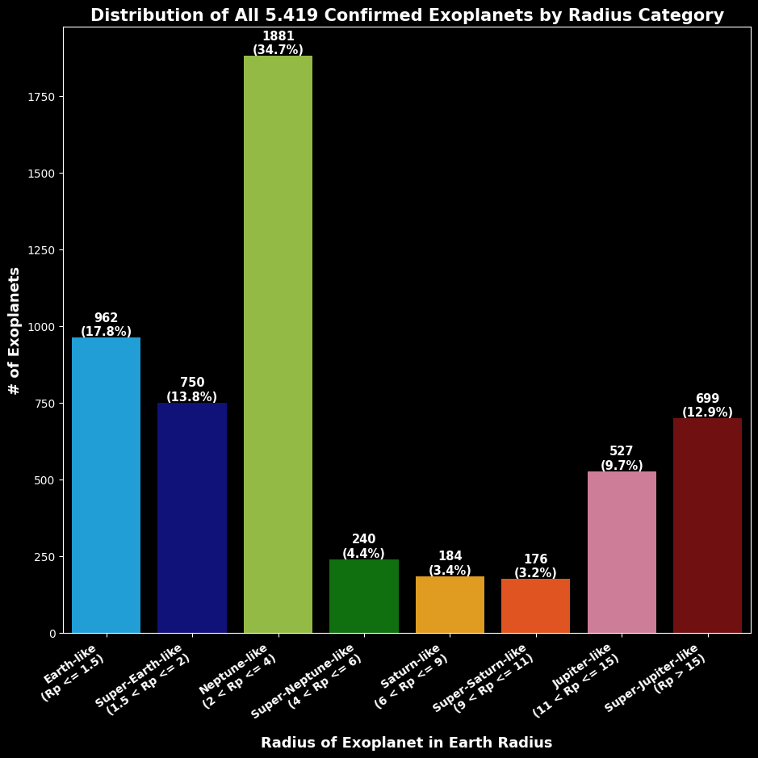 Figure 14: Bar Grah of the Distribution of all 5,419 Confirmed Exoplanets by Radius Category

Based on the graph in (Fig. 13), a majority of the confirmed exoplanets were found to be Super-Earth-Like in mass at 37.2%, followed by Jupiter-Like at 15.1%and Neptune-Like at 14.7%. 12% of exoplanets exhibited Earth-Like mass. Based on the graph in (Fig. 14), a majority of confirmed exoplanets were found to be Neptune-Like at 34.7% followed by Earth-Like and Super-Earth-Like at 17.8% and 13.8% respectively. A large minority of exoplanets at 12.9% were found to be Super-Juptier-Like. These statistics show overall positive insight in finding Earth-Like and Super-Earth-Like planets in terms of mass and radius. An important note however, given that missing mass and radii were imputed using approximations, the results from Figs. 13-14 should therefore be treated at estimations.
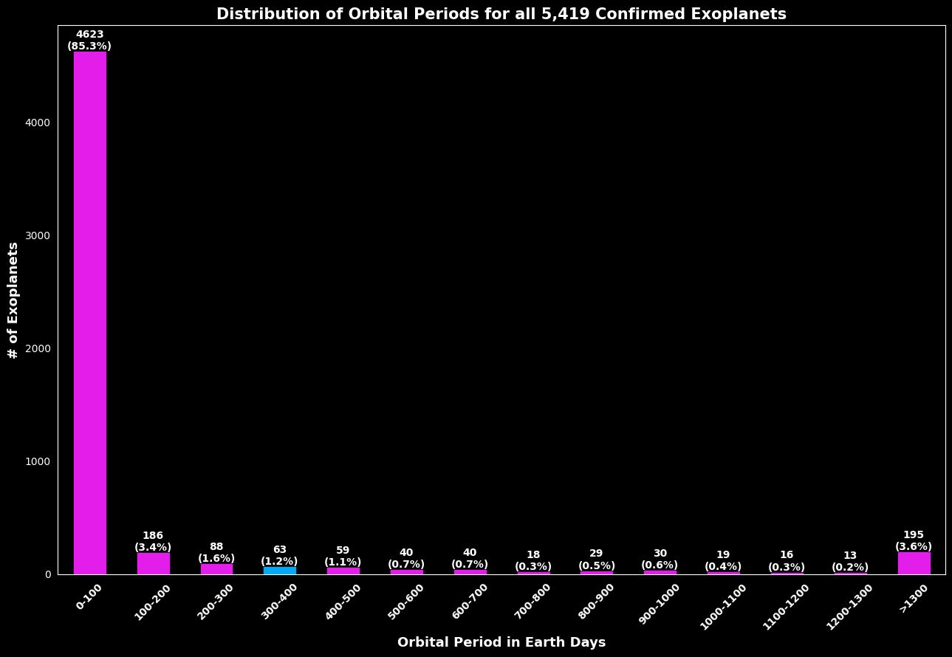
Figure 15: Bar Graph of Distribution of Orbital Periods for all Confirmed Exoplanets
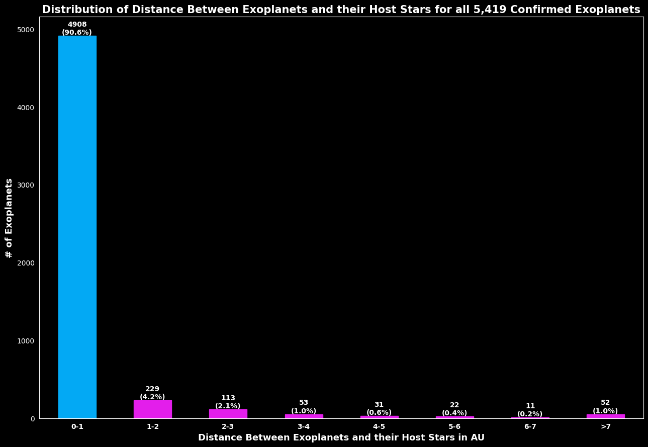
Figure 16: Bar Graph of Distribution of Orbital Semi Major Axis (Orbital Distance) for all Confirmed Exoplanets

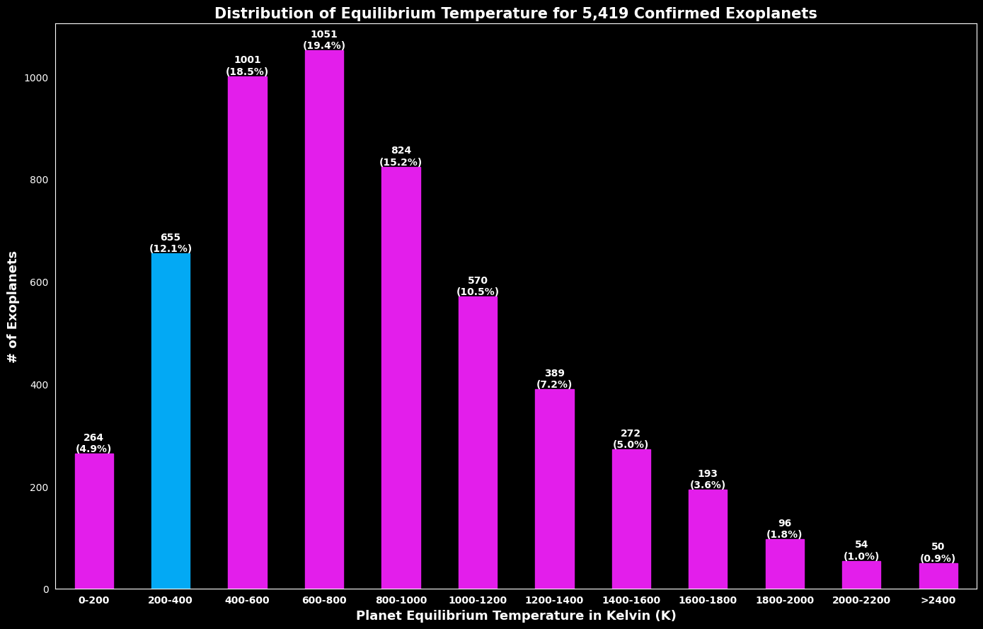
Figure 17: Bar Graph of Distribution of Equilibrium Temperature for all Confirmed Exoplanets

The graphs in (Figs. 15-17) display additional parameters used to assess Earth-Like similarity such as orbital semi major axis, orbital period, and planetary equilibrium temperature respectively. These graphs revealed that only 1.2% of all exoplanets possess an orbital period between 300 – 400 days while a vast majority had significantly shorter orbital periods between 0 – 100 days at 85.3%. However, a surprising 90.6% of all confirmed exoplanets had orbital distances between 0-1 AU. Lastly, while the majority of exoplanets were hotter than Earth ranging between 800-1000 Kelvin at 19.4%, approximately 12.1% were found to be similar to Earth’s equilibrium temperature between 200-400 Kelvin.
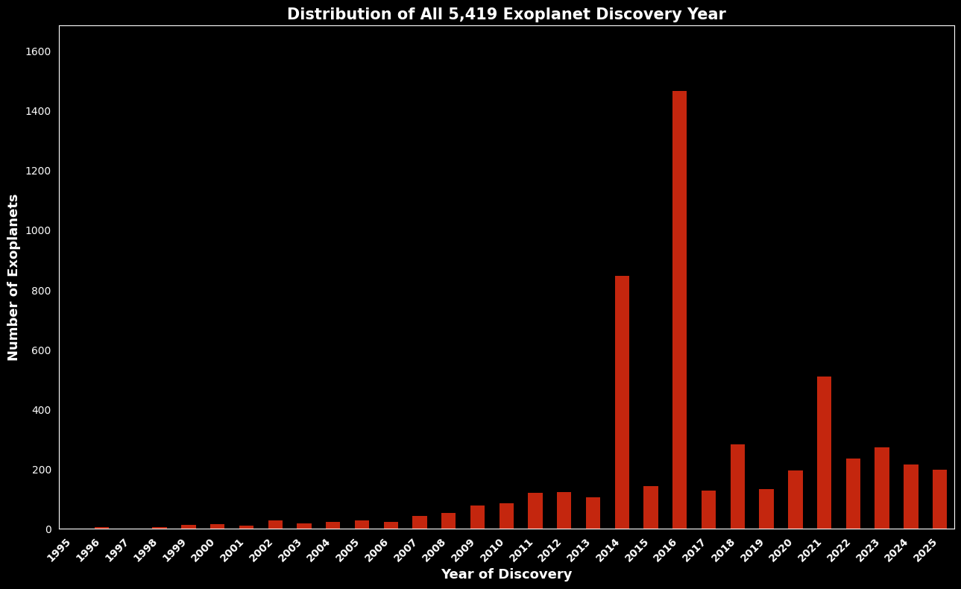
Figure 18: Bar Graph of Distribution of Exoplanet Discoveries by Year of Discovery

Based on the graph in (Fig.18), there appeared to be surges in exoplanets discoveries in the years 2014, 2016, 2018, and 2021. These years correspond to the year, or a few years after, major missions launched such as the K2 mission which launched in 2014 and the TESS mission which launched in 2018.

- K Nearest Neighbor (KNN) Models
To identify the top 10 most Earth-Like exoplanets, the supervised learning model K-Nearest Neighbor (KNN) was used as a similarity-ranking algorithm in feature space. KNN is a non-parametric algorithm, meaning it does not assume any underlying distribution of the data. Therefore, making it an appropriate choice for exoplanet data which often displays skewed distributions. KNN also assumes that similar data points are likely to belong to the same class or have similar target values. This provides an optimistic avenue to identify the natural groupings of the most Earth-Like exoplanets.
Each feature of the exoplanet was compared to the features of a synthetically created “target row” Earth. Each exoplanet and the synthetic Earth are represented as datapoints. The similarity between an exoplanet and the synthetic Earth was measured via a distance between Earth and the exoplanet where the shorter the distance between the two datapoints, the closer the datapoints, and hence the more similar the datapoints are to one another or in other words, the more similar the exoplanet is to Earth.
Two KNN models using two different distance metrics were utilized for this analysis. The results from both KNN models were compared to verify the accuracy of top 10 Earth-Like exoplanets. KNN Model #1 used the Manhattan Distance and KNN Model #2 used the Euclidean Distance. Both models will use the Minkowski Distance which was fine-tuned based on the value p=1 (corresponding to the Manhattan Distance) and p=2 (corresponding to the Euclidean Distance).
The Euclidean Distance is the straight-line distance between two datapoints in Euclidean space. It penalizes more harshly for large deviations within the data which makes it more sensitive to outliers or features which dominate the data. Therefore, it is best suited for determining overall similarity with minimal deviations. It works best for continuous and non-categorical data. For two datapoints $P(x_{1},y_{1})$ and $Q(x_{2},y_{2})$, the Euclidean Distance is calculated as:
$$d(P,Q)=\sqrt{{(x_{2}-x_{1})}^{2}+{(y_{2}-y_{1})}^{2}}$$
In higher dimensions (for n-dimensional data), the formula generalizes to:
$$d(P,Q)=\sqrt{\sum_{i=1}^{n}{{(x_{i}-y_{i})}^{2}}}$$
The Manhattan Distance measures the absolute differences between coordinates. It prioritizes the overall distributed similarity across all features. Therefore, it is more robust to outliers and large deviations for a given feature compared to the Euclidean Distance. It treats all feature deviations linearly and works best for high-dimensional data. For two datapoints $P(x_{1},y_{1})$ and $Q(x_{2},y_{2})$, the Manhattan Distance is calculated as:
$$d(P,Q)=\left|x_{2}-x_{1}\right|+\left|y_{2}-y_{1}\right|$$
In higher dimensions (for n-dimensional data), the formula generalizes to:
$$d(P,Q)=\sum_{i=1}^{n}{{\left|x_{i}-y_{i}\right|}^{2}}$$
Minkowski distance is a generalized form of both Euclidean and Manhattan distances. It is controlled by a fine-tuning parameter p where p=1 refers to the Manhattan Distance and p=2 refers to the Euclidean Distance. The formula for Minkowski distance is:
$$d(P,Q)={\left(\sum_{i=1}^{n}{{\left|x_{i}-y_{i}\right|}^{p}}\right)}^{1/p}$$
All features of each exoplanet and its host star were normalized to be in terms of the Earth and the Sun respectively. Afterwards, One Hot Encoder was used to encode categorical spectral type columns into 21 new binary columns corresponding to the 21 unique entries in the spectral type column: GIII, KIII, KV, GV, GIV, KIV, MV, sdB, FIV, FV, KII, SD, AV, MIII, AIII, BV, AIV, WD, T, BIV, GII.
The feature weighting scheme for Earth-Like exoplanet identification was based on astrophysical principles used to determine Earth-Like similarity and potential habitability. Features with greater importance in determining the Earth-Like similarity of an exoplanet and subsequent habitability potential received higher weights. This included habitability-critical parameters which received the highest weight of 7.0 and included orbital period, habitable zone range, and GV spectral type classification. A high weight of 6.0 was assigned to equilibrium temperature and orbital semi major axis, as these parameters govern planetary radiative balance and stellar flux. Even small variations in orbital distance can significantly alter the energy received by a planet from its host star. This weighting aligns with classical habitable zone modeling and energy balance studies. A moderate weight of 5.0 was assigned to planetary radius since the planet size provides insight into planet composition. This is critical for identifying Earth-Like exoplanets which are rocky planets.
Lower weights of 1.5 were assigned to stellar mass and radius to prioritize exoplanets orbiting a Type-G Sun-Like star. However, heavy weighting was not applied to avoid over-weighting and redundancy since the equilibrium planet temperature and habitable zone range parameters already provides insight into these physical characteristics. Planet mass was assigned a baseline eight of 1.0 despite its physical importance in determining Earth-Like similarity. Manu exoplanets lacked precise mass measurement due to physical observational constraints for far exoplanets. Therefore, over-weighting this parameter could bias the model toward well-characterized systems rather than truly Earth-like ones. Furthermore, since mass and radius are correlated, radius alone already provides substantial compositional insight. Similarly, stellar surface gravity, stellar luminosity, and stellar effective temperature were assigned baseline weights of 1.0, as their effects are indirectly incorporated through equilibrium temperature and the habitable zone range. Assigning higher weights to these parameters would risk double-counting stellar influences. Finally, all non-GV spectral types were also given baseline weights of 1.0 to avoid overly penalizing type MV and KV stars which are capable of sustaining life. While the KNN models maintain a strong preference for solar analogs through the heavy-weighted GV stars, it preserves flexibility by not excluding other stellar types entirely. This approach reflects a conservative astrophysical bias that prioritizes Sun-like systems while remaining open to alternative habitable environments.

- K-Means Clustering Models
To automatically categorize exoplanets into their natural planetary groupings, three clustering models were used and their results were compared to verify validity of categorization capabilities for all three clustering models. Clustering does not require predefined labels, so it automatically identifies patterns or structures within the dataset by grouping similar datapoints. Each cluster represented a specific planetary system an exoplanet could be categorized under.
The first clustering model utilized was the K Means Clustering model which is an unsupervised learning technique used to group data points into k number of clusters based on their shared characteristics by taking the Euclidean distance between datapoints and the centroids of each cluster. K Means assumes data forms spherical clusters which are all similar in size with equal density.
Features which exhibit greater ranges compared to other features tend to bias the model. Therefore, after categorical features were encoded using One Hot Encoder, the features were normalized in terms of Earth’s features and then scaled. The model assumes clusters exhibit a spherical structure. However, astrophysical data often contains outliers which can skew and distort centroids of clusters. To handle this, planets whose z-score was beyond 6 standard deviations from the mean and would subsequently skew the centroids were removed. This resulted in 535 outlier planets being removed. The number of clusters were set to k=4.
The K Means clusters were interpreted by using the centroid values of each cluster. The centroid is the average location or value of all datapoints (planets) in a cluster in feature space. Therefore, the centroid represents the average planetary system for each cluster. The centroid values were converted back into real astrophysical units so that the physical meaning of the average values could be interpreted for each cluster based on astrophysical properties. This interpretation was grounded in astrophysical knowledge rather than just statistical patterns.
The K Means clustering model was applied to all confirmed exoplanets of the dataset then the model ran on the top 10 Earth-Like planets to conduct a cross validation of results. The results from this showed that the K Means model can naturally and correctly group exoplanets into planetary systems based on the characteristics of their host stars. However, it was unable to identify the natural grouping of exoplanets based on planetary structure.

- Gaussian Mixture Models (GMM)
To improve upon the K Means cluster model to identify the natural groupings of exoplanets, a second clustering model is used. The Gaussian Mixture Model (GMM), which is an unsupervised learning technique, assumes the data is normally distributed and clusters datapoints as k number of distinct Gaussian distributions with each representing a cluster with its own mean, covariance, and mixing weight. GMM accounts for the probability of a datapoint belonging to a specific cluster unlike K Means. This allows a datapoint to have different probabilities of belonging to different clusters where the datapoint is assigned to the cluster with the highest probability. Unlike K Means, GMM does not assume data forms spherical clusters nor that the clusters are the same size. Therefore, GMM is more flexible for clusters with different shapes and orientations, allowing it to form elliptical clusters and capture overlapping and complex planetary system structures.
The GMM clusters were interpreted by analyzing the mean and covariance matrix of each cluster which are represented by gaussian distributions. Similar to the K Means clusters, the mean represents the center of that cluster in feature space which represents the average planetary system for each cluster. The covariance matrix describes how the features vary and relate to each other within that cluster. This describes the relationship between features for a particular cluster. Similar to the K Means model, the interpretation of each cluster was based on known astrophysical thresholds/
Similar to the K Means model, the categorical features were encoded using One Hot Encoder then all features were normalized then scaled to be in terms of Earth’s and the Sun’s features. The same 535 outlier planets were removed, and the number of clusters were set to k=4 to ensure consistency between both the K Means and GMM models.
While GMM improved upon K Means in differentiating clusters to include all stellar properties as well as planet mass and radius, while also accounting for clusters of different shapes and sizes, it assumed the data is normally distributed. However, some astrophysical parameters typically exhibit skewed distributions due to observation and measurement limitations of current detection methods. Additionally, both GMM and K Means required the use of the z-score method to remove outliers with a threshold that can be fine-tuned.

- Hierarchical Density-Based Spatial Clustering (HDBSCAN) Model
To improve upon GMM and K Means, a third clustering algorithm was utilized. Hierarchical Density-Based Spatial Clustering (HDBSCAN) is an unsupervised learning algorithm that finds clusters of varying density by building a hierarchy of clusters, separating them from sparse noise, and selecting the most stable clusters. The sparse noise datapoints are automatically detected and represent outlier planets which exhibit unusual or extreme features that do not fit into a dense region. These dense regions represent a specific cluster, or planetary system. These outlier planets are then automatically removed by the model without the need to set a specific threshold. Additionally, it does not require a fixed density threshold to find clusters. HDBSCAN does not assume clusters form a specific shape, size, nor distribution.
HDBSCAN requires a minimum cluster size which refers to the minimum number of datapoints, or planets, required to form a cluster. A minimum of 15 planets were required to form a cluster. A minimum number of nearby datapoints, or planets, which share similar features are required to be a part of a single dense cluster. Therefore, a minimum of 5 planets were required to be near by to form the dense cluster.
The interpretation for the HBDSCAN clusters followed a similar procedure to the GMM clusters by looking at the mean for each cluster which resents the average planetary system. Similar to both he K Means and GMM models, the interpretation of the clusters were based off of astrophysical thresholds.
HDBSCAN was able to successfully differentiate clusters based on all stellar and planetary parameters including the parameter for determining whether a planet is within its star’s habitable zone.

Results
- KNN Modeling Results
The top Earth-Like exoplanet was found to be Kepler-452 b in the weighted feature space when using both distance metrics. This also suggests strong habitability due to Kepler-452 b and its start Kepler-452 exhibiting the strongest similarity to Earth and the Sun respectively. This can be referenced in Table 5. This can be verified by studies conducted by NASA [31] which have confirmed that Kepler-452 b currently remains the closest match to Earth.
Using the Manhattan Distance, Kepler-452 b had a feature difference of 10.146 units away from Earth. There was a significant gap in the feature differences between Kepler-452 b and all other top Earth-analog candidates which emphasizes the unique composition of Kepler-452 b. Similarly, using the Euclidean Distance yields the same results where Kepler-452 b approximately had a feature difference of only 5.241 units away from Earth.

Top 10 Earth-Like Exoplanets KNN Model Comparison
Rank | KNN Model #1 | Manhattan Distance | KNN Model #2 | Euclidean Distance
1 | Kepler-452 b | 10.1463 | Kepler-452 b | 5.2408
2 | Kepler-1638 b | 16.6309 | Kepler-1638 b | 7.1452
3 | Kepler-51 e | 16.7816 | Kepler-51 e | 7.7652
4 | Kepler-1606 b | 19.284 | Kepler-1606 b | 8.2007
5 | Kepler-1701 b | 20.1409 | Kepler-1701 b | 8.466
6 | Kepler-22 b | 20.8885 | Kepler-1126 c | 9.4643
7 | Kepler-1126 c | 22.4542 | Kepler-69 c | 9.9627
8 | Kepler-1549 b | 22.9228 | Kepler-1185 b | 10.35
9 | Kepler-1690 b | 23.2328 | Kepler-442 b | 10.3699
10 | Kepler-69 c | 23.5054 | Kepler-311 d | 10.3847
Table 9: Shows the top 10 Earth-Like exoplanets found from the KNN Model #1 (Manhattan Distance) and KNN Model #2 (Euclidean Distance). The top 5 Earth-Like exoplanets remain consistent showing robustness.

The top Earth-Like exoplanets (1-5) all remained consistent in their rankings This indicates that while the strongest Earth analogs are robust to metric choice, mid-tier candidates (ranks 6–10) are sensitive to how feature deviations are aggregated. There is particularly increased sensitivity to metric choice in regions of feature space where similarity is less tightly constrained. The stability of the top 5 candidates across both distance metrics suggests that the highest-ranked candidates form a robust well-defined similarity cluster in weighted feature space, while lower-ranked candidates occupy a transitional region where similarity is less defined and more dependent on metric formulation. This indicates that the Manhattan Distance is better suited to compare how similar each feature combined compares to Earth. While the Euclidean Distance is better suited to compare how similar each feature is to Earth while minimizing deviations. Therefore, rather than identifying a single superior metric, the comparison highlights complementary perspectives on planetary similarity.
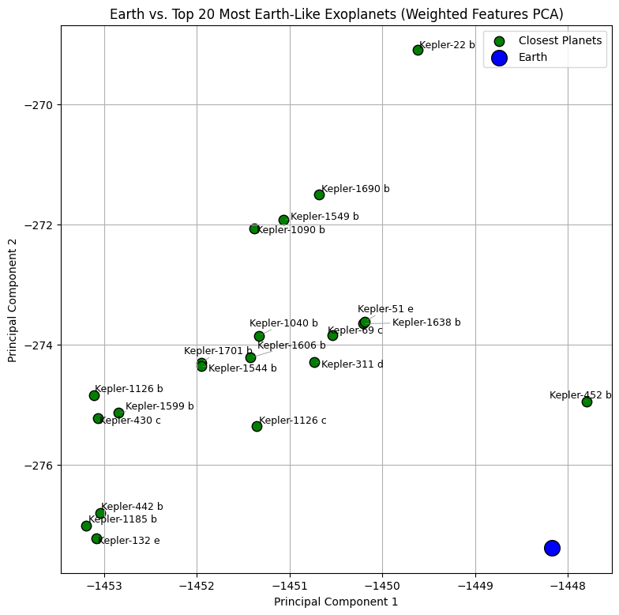
Figure 19. PCA Graph which depicts the top 20 Earth-Like exoplanets (shown in green) in proximity to Earth (shown in blue).
Principal Component Analysis (PCA) was used to conduct dimensionality reduction to reduce all 34 features into 2 principal components to then visualize where the top 20 most Earth-Like exoplanets lie compared to Earth on a 2D plane. The PCA visualization in (Fig. 19). shows that of the top 20 planets, the top 10 cluster closer near Earth in the reduced two-dimensional projection, indicating stable similarity relationships in high-dimensional space. Earth appears to be on the outer edge of the similarity cluster of the top 10 Earth-Like exoplanets which indicates the unique composition of Earth compared to all astrophysical populations. Kepler-452 b appears to be the closest to Earth, showing its close similarity to Earth. Interestingly, Kepler-22 b appears to be separated from all other clusters of planets. This is supported by the fact that despite all its features displaying strong similarity to Earth, its mass is Neptune-Like at 9.1 times. Some dispersion among lower-ranked candidates is observed, consistent with increased metric sensitivity beyond the strongest analogs. Overall, PCA visualization supports the robustness of the highest-ranked Earth analogs.

- K-Means Clustering Modeling Results
The K Means Clustering model automatically revealed 4 clusters which can be referenced in the PCA Visualization in (Fig. 20). The 4 clusters exoplanets were grouped into are:
- Cluster 0: Type K Main Sequence Star Planetary system
- Cluster 1: Sun-Like Planetary System
- Cluster 2: Red Dwarf Planetary System
- Cluster 3: Type F Main Sequence Star Planetary system
The dominant features which differentiated each cluster were stellar features such as the spectral type, stellar effective temperature, luminosity, radius, and mass. All planetary features were not able to accurately separate clusters due to the high variability within planetary features.
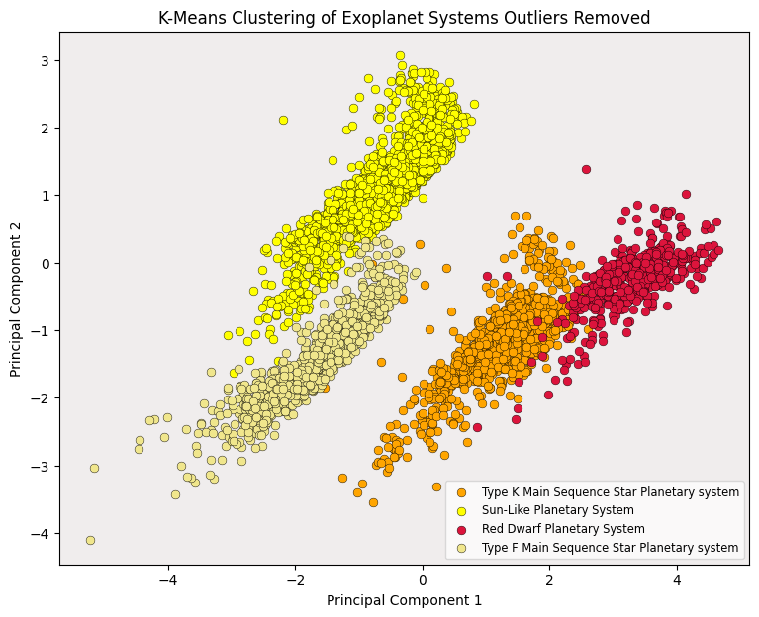
Figure 20: Graph shows the 4 clusters identified by the K-Means Cluster model for all confirmed exoplanets with 535 outlier exoplanets removed due to anomalous features present.

The Silhouette Score is a metric used to evaluate the quality of clusters in clustering analysis. It provides a measure of how similar each point is to its own cluster compared to other clusters. It ranges from -1 to 1, where 1 indicates that points are well matched to their own cluster and distinct from other clusters, 0 indicates overlapping clusters, meaning the boundary between clusters is unclear, and -1 indicates that points are likely assigned to the wrong cluster, meaning they are closer to points in a different cluster. The resulting silhouette score was 0.483, which implies the model was able to moderately separate clusters with minor overlapping present.
After running the model on the top 10 Earth-Like exoplanets, the model was able to correctly predict the planetary system the top 10 exoplanets (found from KNN model #1 and KNN model #2) belong to. Where all were found to belong to a Sun-Like planetary system with the exception of Kepler-442 b (found from KNN model #2) which orbits a KV star rather than a GV star and thus, was predicted to belong to a Type K Main Sequence Planetary System. Table 6 shows all top 10 Earth-Like planets where for all top 5 planets, all were automatically predicted to belong to a Sun-Like planetary system based on their spectral type and stellar features.
K-Means Clustering Results for Top 5 Earth-Like Exoplanets
Top 10 Earth-Like Exoplanets using Manhattan Distance (KNN Model #1 Results) |  |  |  | Top 10 Earth-Like Exoplanets using Euclidean Distance (KNN Model #2 Results)
Rank | Planet | Cluster_ID | Cluster_Type (Planetary System) | Rank | Planet | Cluster_ID | Cluster_Type (Planetary System)
1 | Kepler-452 b | 1 | Sun-Like Planetary System | 1 | Kepler-452 b | 1 | Sun-Like Planetary System
2 | Kepler-1638 b | 1 | Sun-Like Planetary System | 2 | Kepler-1638 b | 1 | Sun-Like Planetary System
3 | Kepler-51 e | 1 | Sun-Like Planetary System | 3 | Kepler-51 e | 1 | Sun-Like Planetary System
4 | Kepler-1606 b | 1 | Sun-Like Planetary System | 4 | Kepler-1606 b | 1 | Sun-Like Planetary System
5 | Kepler-1701 b | 1 | Sun-Like Planetary System | 5 | Kepler-1701 b | 1 | Sun-Like Planetary System
6 | Kepler-22 b | 1 | Sun-Like Planetary System | 6 | Kepler-1126 c | 1 | Sun-Like Planetary System
7 | Kepler-1126 c | 1 | Sun-Like Planetary System | 7 | Kepler-69 c | 1 | Sun-Like Planetary System
8 | Kepler-1549 b | 1 | Sun-Like Planetary System | 8 | Kepler-69 c | 1 | Sun-Like Planetary System
9 | Kepler-1690 b | 1 | Sun-Like Planetary System | 9 | Kepler-442 b | 0 | Type K Main Sequence Star Planetary system
10 | Kepler-69 c | 1 | Sun-Like Planetary System | 10 | Kepler-442 b | 1 | Sun-Like Planetary System
Table 6: shows the K-Means Clustering model predicted the top Earth-Like exoplanets found from the KNN Model #1 and KNN Model #2 into their correct planetary systems.

- GMM Modeling Results
The GMM model automatically revealed 4 clusters which can be referenced in the PCA Visualization in ( (Fig. 21). The 4 clusters exoplanets were grouped into are:
- Cluster 0: Type K Main Sequence stars hosting Earth-sized rocky planets
- Cluster 1: Sun-Like stars hosting Earth-sized and Super-Earth-sized rocky planets
- Cluster 2: Cool red dwarf stars hosting Earth-sized rocky planets
- Cluster 3: Type F Main Sequence stars hosting warm Earth-sized rocky planets
The features which differentiated each cluster of the GMM model included all stellar properties similar to the K Means model. However, it improved upon the K Means model by defining clusters based on all stellar properties in addition to planet mass and radius.
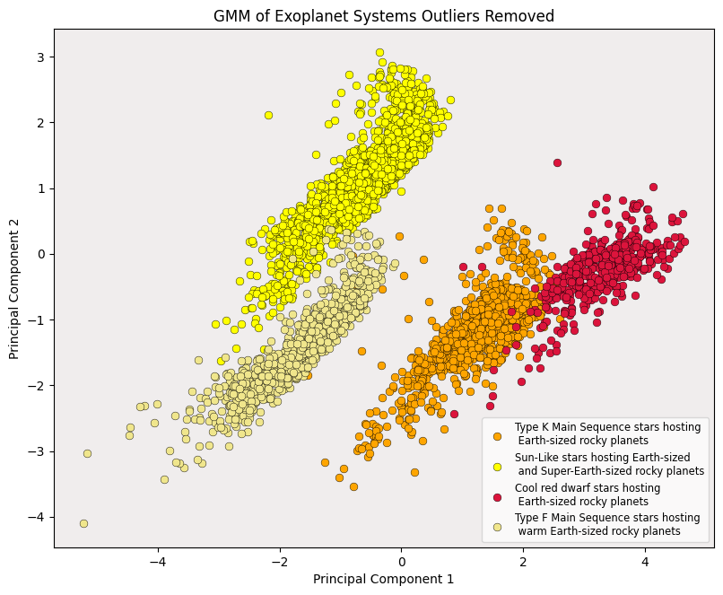
Figure 21: Graph shows the 4 clusters identified by the GMM model for all confirmed exoplanets with 535 outlier exoplanets removed due to anomalous features present.

The silhouette score remained consistent with the K Means model with a score of 0.483 which implies the model performed well at separating the data into distinct clusters with minor overlap.
GMM has the ability to display how confident the model was in assigning exoplanets to a particular cluster. Where a close to 1.0 indicates planet clearly belongs to one cluster rather than between clusters. This helps to evaluate the overall confidence of the model in assigning a planet to the correct cluster. Based on (Fig. 22). each exoplanet has a most planets have >99% probability of belonging to their assigned cluster. Therefore, the GMM is very confident about cluster membership and clusters are well separated in the feature space.
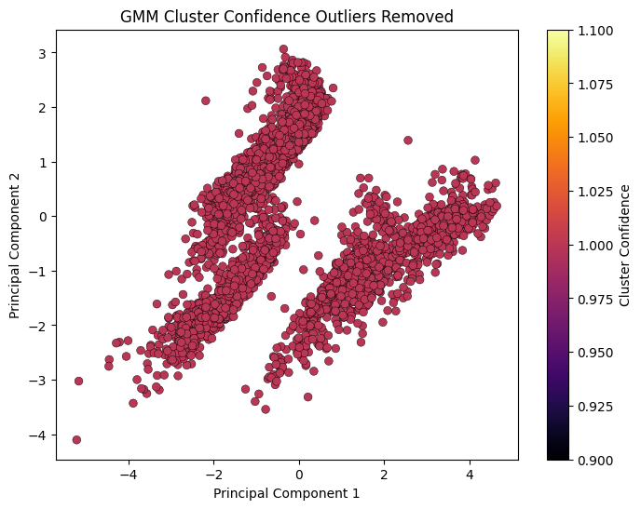
Figure 22: Graph shows the 4 clusters identified by the GMM which are consistent with the K-Means model. This shows the confidence of the model in assigning all exoplanets to their appropriate clusters. Most planets have >99% probability of belonging to the correct cluster.

Similar to the K Means model; after running the model on the top 10 Earth-Like exoplanets, the model was able to correctly predict the planetary system the top 10 exoplanets (found from KNN model #1 and KNN model #2) belong to. All top 10 Earth-Like exoplanets with the exception of Kepler-442 b were predicted to belong to a planetary system of a Sun-Like star hosting Earth-sized and Super-Earth-sized rocky planets. Kepler-442 b was predicted to belong to a planetary system of a Type K Main Sequence stars hosting Earth-sized rocky planets. This can be referenced in Table 7.

Top 10 Earth-Like Exoplanets using Manhattan Distance  (KNN Model #1 Results) |  |  |  | Top 10 Earth-Like Exoplanets using Euclidean Distance  (KNN Model #2 Results)
Rank | Planet | Cluster_Type  (Planetary System) | Cluster Probability | Rank | Planet | Cluster_Type (Planetary System) | Cluster Probability
1 | Kepler-452 b | Sun-Like star hosting Earth-sized and Super-Earth-sized rocky planets | 100% | 1 | Kepler-452 b | Sun-Like star hosting Earth-sized and Super-Earth-sized rocky planets | 100%
2 | Kepler-1638 b | Sun-Like star hosting Earth-sized and Super-Earth-sized rocky planets | 100% | 2 | Kepler-1638 b | Sun-Like star hosting Earth-sized and Super-Earth-sized rocky planets | 100%
3 | Kepler-51 e | Sun-Like star hosting Earth-sized and Super-Earth-sized rocky planets | 100% | 3 | Kepler-51 e | Sun-Like star hosting Earth-sized and Super-Earth-sized rocky planets | 100%
4 | Kepler-1606 b | Sun-Like star hosting Earth-sized and Super-Earth-sized rocky planets | 100% | 4 | Kepler-1606 b | Sun-Like star hosting Earth-sized and Super-Earth-sized rocky planets | 100%
5 | Kepler-1701 b | Sun-Like star hosting Earth-sized and Super-Earth-sized rocky planets | 100% | 5 | Kepler-1701 b | Sun-Like star hosting Earth-sized and Super-Earth-sized rocky planets | 100%
6 | Kepler-22 b | Sun-Like star hosting Earth-sized and Super-Earth-sized rocky planets | 100% | 6 | Kepler-1126 c | Sun-Like star hosting Earth-sized and Super-Earth-sized rocky planets | 100%
7 | Kepler-1126 c | Sun-Like star hosting Earth-sized and Super-Earth-sized rocky planets | 100% | 7 | Kepler-69 c | Sun-Like star hosting Earth-sized and Super-Earth-sized rocky planets | 100%
8 | Kepler-1549 b | Sun-Like star hosting Earth-sized and Super-Earth-sized rocky planets | 100% | 8 | Kepler-69 c | Sun-Like star hosting Earth-sized and Super-Earth-sized rocky planets | 100%
9 | Kepler-1690 b | Sun-Like star hosting Earth-sized and Super-Earth-sized rocky planets | 100% | 9 | Kepler-442 b | Type K Main Sequence stars hosting Earth-sized rocky planets | 100%
10 | Kepler-69 c | Sun-Like star hosting Earth-sized and Super-Earth-sized rocky planets | 100% | 10 | Kepler-442 b | Sun-Like star hosting Earth-sized and Super-Earth-sized rocky planets | 100%
Table 7: shows the GMM model predicted the top Earth-Like exoplanets found from the KNN Model #1 and KNN Model #2 into their correct planetary systems.

- HDBSCAN Modeling Results
Unlike K Means or GMM which relies on a predefined number of clusters k when fitting the model, HDBSCAN automatically discovers n number of clusters after fitting the model. The HDBSCAN model automatically identified 17 clusters corresponding to different planetary systems and 1 cluster for the outlier planets group. Additionally, 118 outlier planets were identified and automatically removed. This can be referenced in (Fig. 23). which shows the sparse datapoints identified as outlier planets. The resulting cluster can be referenced in (Fig. 24).
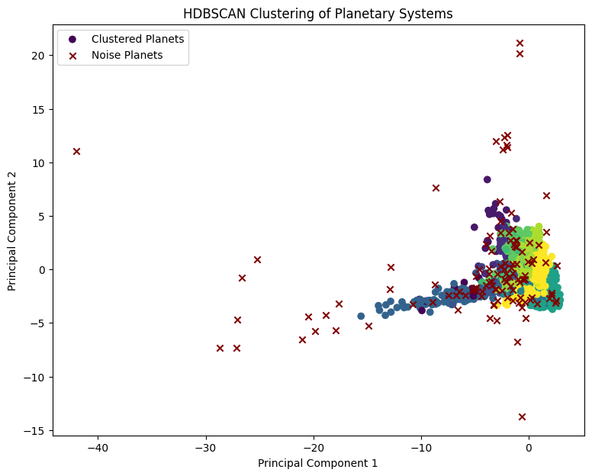 | 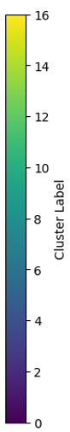
Figure 23: Graph shows 17 clusters identified by the HDBSCAN model where planets which successfully belong to a dense cluster appear as colored circular datapoints and outlier planets which are sparsely scattered appear as a cross.
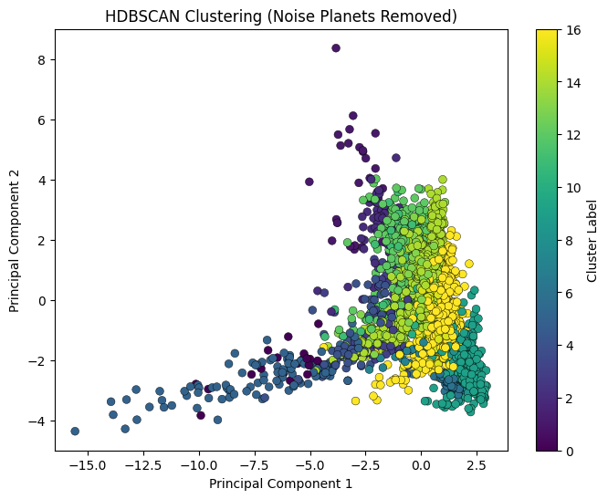
Figure 24: Graph shows 17 clusters identified by the HDBSCAN model where outlier planets are automatically removed.

Similar to GMM, HDBSCAN has the ability to determine the probability of a planet belonging to a specific cluster. Therefore, a minimum of 80% confidence was used to visualize the clusters with outlier planets removed as shown in (Fig. 25). The resulting graph with the most confident cluster membership planets with outlier planets removed can be referenced in (Fig. 26).
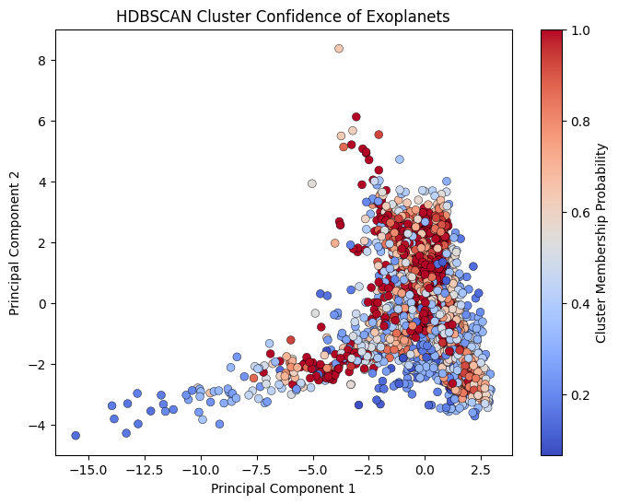
Figure 25: Graph shows 17 clusters identified by the HDBSCAN model where the cluster membership for each exoplanet is displayed from highest cluster membership (shown in dark maroon) to lowest cluster membership (shown in dark blue).
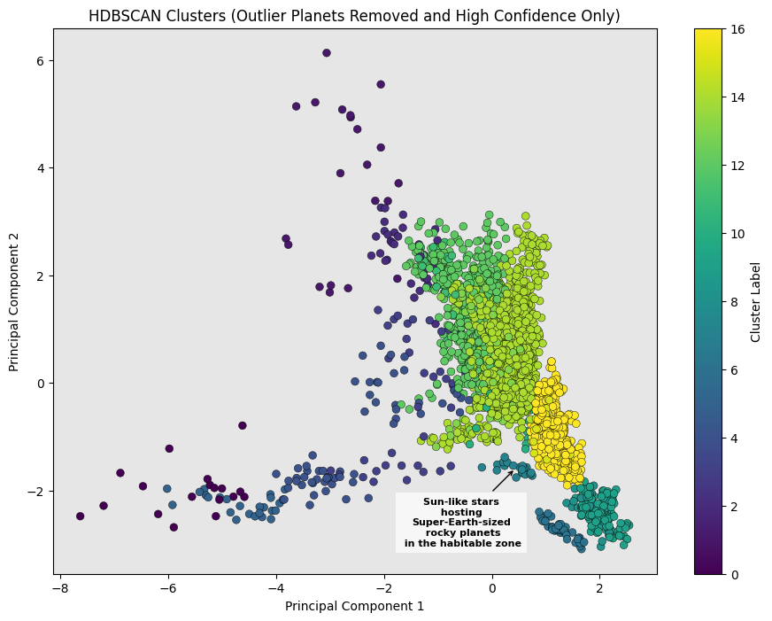
Figure 26: Graph shows 17 clusters identified by the HDBSCAN model for all exoplanets where outlier exoplanets and exoplanets with membership probability < 80% automatically removed.

Similar to the K Means and GMM models, the HDBSCAN model was then run on the top 10 Earth-Like exoplanets which correctly predicted all planets belonging to their appropriate planetary systems with a high confidence given the minimum threshold of 80% confidence. This revealed that all exoplanets except Kepler-442 b correctly belonged to a Sun-like planetary system hosting Super-Earth-sized rocky planets in the habitable zone. Kepler-442 b was predicted to belong to a Type K Main Sequence star planetary system hosting Earth-sized rocky planets in the habitable zone. Almost all planets had a 100% confidence of belonging to their correct clusters with only Kepler-1638 b and Kepler-442 b having a confidence of 85.7% and 82.3% respectively. This can be referenced in Table 8.
Top 10 Earth-Like Exoplanets using Manhattan Distance  (KNN Model #1 Results) |  |  |  | Top 10 Earth-Like Exoplanets using Euclidean Distance  (KNN Model #2 Results)
Rank | Planet | Cluster_Type  (Planetary System) | Cluster Probability | Rank | Planet | Cluster_Type (Planetary System) | Cluster Probability
1 | Kepler-452 b | Sun-like stars hosting Super-Earth-sized rocky planets in the habitable zone | 100% | 1 | Kepler-452 b | Sun-like stars hosting Super-Earth-sized rocky planets in the habitable zone | 100%
2 | Kepler-1638 b | Sun-like stars hosting Super-Earth-sized rocky planets in the habitable zone | 85.7% | 2 | Kepler-1638 b | Sun-like stars hosting Super-Earth-sized rocky planets in the habitable zone | 85.7%
3 | Kepler-51 e | Sun-like stars hosting Super-Earth-sized rocky planets in the habitable zone | 100% | 3 | Kepler-51 e | Sun-like stars hosting Super-Earth-sized rocky planets in the habitable zone | 100%
4 | Kepler-1606 b | Sun-like stars hosting Super-Earth-sized rocky planets in the habitable zone | 100% | 4 | Kepler-1606 b | Sun-like stars hosting Super-Earth-sized rocky planets in the habitable zone | 100%
5 | Kepler-1701 b | Sun-like stars hosting Super-Earth-sized rocky planets in the habitable zone | 100% | 5 | Kepler-1701 b | Sun-like stars hosting Super-Earth-sized rocky planets in the habitable zone | 100%
6 | Kepler-22 b | Sun-like stars hosting Super-Earth-sized rocky planets in the habitable zone | 100% | 6 | Kepler-1126 c | Sun-like stars hosting Super-Earth-sized rocky planets in the habitable zone | 100%
7 | Kepler-1126 c | Sun-like stars hosting Super-Earth-sized rocky planets in the habitable zone | 100% | 7 | Kepler-69 c | Sun-like stars hosting Super-Earth-sized rocky planets in the habitable zone | 100%
8 | Kepler-1549 b | Sun-like stars hosting Super-Earth-sized rocky planets in the habitable zone | 100% | 8 | Kepler-69 c | Sun-like stars hosting Super-Earth-sized rocky planets in the habitable zone | 100%
9 | Kepler-1690 b | Sun-like stars hosting Super-Earth-sized rocky planets in the habitable zone | 100% | 9 | Kepler-442 b | Type K Main Sequence stars hosting Earth-sized rocky planets in the habitable zone | 82.3%
10 | Kepler-69 c | Sun-like stars hosting Super-Earth-sized rocky planets in the habitable zone | 100% | 10 | Kepler-442 b | Sun-like stars hosting Super-Earth-sized rocky planets in the habitable zone | 100%
Table 8: shows the HDBSCAN model predicted the top Earth-Like exoplanets found from the KNN Model #1 and KNN Model #2 into their correct planetary systems.

Conclusion and Future Work
Based on the results obtained from the exploratory data analysis (EDA) of the dataset, a majority of confirmed exoplanets are found to be rocky Super-Earth massed Neptune-sized planets orbiting Sun-Like stars within the Galactic Habitable Zone (GHZ).
The results from both KNN Model #1 and KNN Model #2 show that K-Nearest Neighbor (KNN) can be used to accurately determine the top Earth-Like candidates where the top 5 Earth-Like planets possess parameters which satisfy the criteria required for habitability. Kepler-452 b remains the closest match to Earth. Following Kepler-452 b, the remaining top 5 Earth-Like exoplanets include Kepler-1638 b, Kepler-51 e, Kepler-1606 b, and Kepler-1701 b. Top 5 Earth-like exoplanets remain consistent using both Manhattan and Euclidean distance metrics. So, top-ranked Earth-Like planets are robust. Mid-ranked candidates are sensitive to distance metric choice. This suggests that similarity rankings are less stable beyond the top candidates.
The results from the three clustering algorithms K-Means, Gaussian Mixture Model (GMM), and Hierarchical Density-Based Spatial Clustering of Applications with Noise (HDBSCAN) show that unsupervised learning techniques through clustering can be used to accurately determine the planetary system of an exoplanet. The results from all three clustering models are consistence for identifying the planetary groupings of the top Earth-Like exoplanets found by both KNN models #1 and #2 which solidifies validity of results. The natural planetary groupings found by all three models show top 5 Earth-Like exoplanets are likely rocky Earth-sized or Super-Earth-sized planets orbiting a Type-G (Sun-Like) star within the Habitable Zone of its stars within the Galactic Habitable Zone. Thus, making the top 5 Earth-Like planets potentially habitable.
K-Means classified planets based on their stellar features. GMM classified planets based on stellar and planetary features. HDBSCAN classified planets based on all key features. GMM’s high membership probability overall indicates model is very confident in correctly assigning all exoplanets (including top 10 Earth-Like exoplanets) to clusters. HDBSCAN’s high membership probability for each cluster also demonstrates a high probability between 85% to 100% confidence in correctly assigning top 10 Earth-Like exoplanets to clusters. The clustering structure for K-Means and GMM models are the same due to manually removing outlier planets while the clustering structure for HBDSCAN model differs due to outlier planet being automatically removed by model.
Overall, this study showed that a structured reproducible frame which integrates exploratory data analysis (EDA) with supervised learning and unsupervised learning can predict Earth-Like similarity by determining the top Earth-Like exoplanets along with their habitability potential as well as their natural planetary system groupings. These planets can also be effectively categorized based on their planetary and stellar parameters while the relationship between these parameters can be efficiently explored. Therefore, such a framework demonstrates how computational methods and modeling can be used to speed up the process to analyze astrophysical data while accelerating the discovery process.
Future work will focus on expanding this study to predict habitability for all exoplanets regardless of their feature similarity to Earth. Additionally, further analysis will be conducted to analyze the planetary structure of outlier exoplanets which exhibit anomalous features from current known planetary structures.

References
[1] S. Sen, S. Agarwal, P. Chakraborty, and K. Singh, “Astronomical big data processing using machine learning: A comprehensive review,” Experimental Astronomy, vol. 53, no. 2, pp. 333–368, 2022.
[2] J. H. Jiang, P. E. Rosen, C. X. Liu, Q. Wen, and Y. Chen, “Analysis of habitability and stellar habitable zones from observed exoplanets,” Galaxies, vol. 12, no. 6, p. 86, 2024.
[3] J.-V. Rodrıguez, I. Rodrıguez-Rodrıguez, and W. L. Woo, “On the application of machine learning in astronomy and astrophysics: A textmining- based scientometric analysis,” Wiley Interdisciplinary Reviews: Data Mining and Knowledge Discovery, vol. 12, no. 5, p. e1476, 2022.
[4] P. Pratyush and A. Gangrade, “Automation of transiting exoplanet detection, identification and habitability assessment using machine learning approaches,” in arXiv preprint arXiv:2112.03298, 2021.
[5] R. Jagtap, U. Inamdar, S. Dere, M. Fatima, and N. B. Shardoor, “Habitability of exoplanets using deep learning,” in 2021 IEEE International IOT, Electronics and Mechatronics Conference (IEMTRONICS). IEEE, 2021, pp. 1–6.
[6] G. K. Jayan, J. Mathew, C. Stephen et al., “Artificial intelligence (AI) to predict earth similarity index (ESI): An analysis of regression models on esi data.” Grenze International Journal of Engineering & Technology (GIJET), vol. 10, 2024.
[7] G. Koumbis, “Examining deep learning artificial neural networks with hyperparameter optimization and ensemble learning in the search for habitable exoplanets: An analysis,” ProQuest Dissertations and Theses, 2024.
[8] M. S. Jakka, “Assessing exoplanet habitability through data-driven approaches: A comprehensive literature review,” arXiv preprint arXiv:2505.11204, 2025.
[9] W. Borucki, D. Koch, G. Basri et al., “The Kepler mission: Finding the sizes, orbits and frequencies of earth-size and larger extrasolar planets,” in Scientific Frontiers in Research on Extrasolar Planets, ser. ASP Conference Series, vol. 294, 2003.
[10] C. H. Lineweaver, Y. Fenner, and B. K. Gibson, “The galactic habitable zone and the age distribution of complex life in the milky way,” Science, 2004.
[11] S. Basak, A. Mathur, A. J. Theophilus, G. Deshpande, and J. Murthy, “Habitability classification of exoplanets: a machine learning insight,” The European Physical Journal Special Topics, vol. 230, no. 10, pp. 2221–2251, 2021.
[12] C. Shallue and A. Vanderburg, “Identifying exoplanets with deep learning: A five planet resonant chain around kepler-80 and an eighth planet around kepler-90,” The Astronomical Journal, 2018.
[13] S. Zucker and R. Giryes, “Shallow transits—deep learning. I. feasibility study of deep learning,” The Astronomical Journal, 2018.
[14] “A convolutional neural network based ensemble model for exoplanet detection,” 2020.
[15] L. Yu, A. Vanderburg et al., “Identifying exoplanets with deep learning III: Automated triage and vetting of tess candidates,” The Astronomical Journal, 2019.
[16] NASA Exoplanet Archive. NASA Exoplanet Archive: Planetary Systems Composite Data. 2026. Available online: https://exoplanetarchive.ipac.caltech.edu/ (accessed on 11 January 2026).
[17] E. Yılmaz, M. E. Artan, and A. B. Yanartaş. “EXOLIFE: Detection and Habitability Estimation of Exoplanets Using Machine Learning Techniques,” Turkish Journal of Remote Sensing, vol. 6, no. 2, pp. 85–96, 2024.
[18] D. Schulze-Makuch, A. Mendez, A.G. Fairen, et al., “A two-tiered approach to assessing the habitability of exoplanets. Astrobiology,” vol. 11, no. 10, 2011.
[19] L.N. Irwin, A Mendez, A.G. Fairen, D. Schulze-Makuch, “Assessing the Possibility of Biological Complexity on Other Worlds, with an Estimate of the Occurrence of Complex Life in the Milky Way Galaxy,” Challenges Journal for Planetary Health, vol. 5, no. 1, pp. 159-174, 2014.
[20] S. Agrawal, S. Basak, S. Saha, K. Bora, J. Murthy, “A Comparative Analysis of the Cobb-Douglas Habitability Score (CDHS) with the Earth Similarity Index (ESI),” arXiv:1804.11176v1, 2018.
[21] K. Bora, S. Sahab, S. Agrawal, M. Safonova, S. Routh, A. Narasimhamurthy, “CD-HPF: New Habitability Score Via Data Analytic Modeling,” arXiv:1604.01722v1, 2016.
[22] J. F. Kasting, R. Kopparapu, R. M. Ramirez, and C. E. Harman, “Remote Life Detection Criteria, Habitable Zone Boundaries, and the Frequency of Earthlike Planets around M and Late-K Stars.” Proceedings of the National Academy of Sciences (PNAS), vol. 111, no. 35, pp. 12641-12646, 2013.
[23] S. Saha, S. Basaka, K. Borab, M. Safonovc, S. Agrawala, P. Sarkara, J. Murthyd, “Theoretical Validation of Potential Habitability via Analytical and Boosted Tree Methods: An Optimistic Study on Recently Discovered Exoplanets,” arXiv:1712.01040v1, 2017.
[24] D. Chia-Tien Lo, et al, “Exoplanet Detection Using Machine Learning Models Trained on Synthetic Light Curves,” arXiv:2507.19520v1, 2025.
[25] N. Schanche, et al, “Machine-learning approaches to exoplanet transit detection and candidate validation in wide-field ground-based surveys” Royal Astronomical Society, vol. 483, no. 4, pp. 5534–5547, 2019.
[26] A. Chaushev, et al, “Classifying Exoplanet Candidates with Convolutional Neural Networks: Application to the Next Generation Transit Survey,” Royal Astronomical Society, vol. 483, no. 4, pp. 5232–5250, 2019.
[27] Y. Jin, L. Yang, C. Chiang, “Identifying Exoplanets with Machine Learning Methods a Preliminary Study,” International Journal on Cybernetics & Informatics (IJCI). vol. 11, no.1, 2022.
[28] S. Mahmood, I. Rahman, S. Sarkar, and A. Mahmood. (2026). Discovering Earth 2.0: A data-driven exploration of NASA’s Exoplanet Dataset. *Proceedings of the IEEE International Conference on Artificial Intelligence, Computer, Data Sciences and Applications (ACDSA 2026)*. (Accepted for publication).
[29] The Habitable Worlds Catalog (HWC). Planetary Habitability Laboratory (PHL) at the University of Puerto Rico (UPR) Arecibo Composite Data. 2026. http://phl.upr.edu/hwc (accessed on 10 February 2026).
[30] S. Müller, J. Baron, R. Helled, F. Bouchy, and L. Parc, "The mass-radius relation of exoplanets revisited," Astronomy & Astrophysics, vol. 686, p. A296, 2024.
[31] NASA, “Kepler-452 b,” NASA Science: Exoplanet Catalog. [Online]. Available: https://science.nasa.gov/exoplanet-catalog/kepler-452-b/. [Accessed: Apr. 15, 2026]

